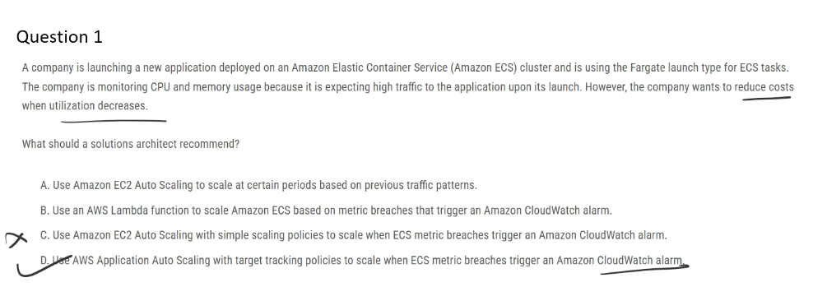

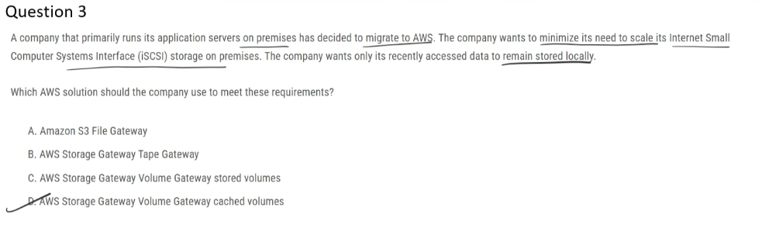

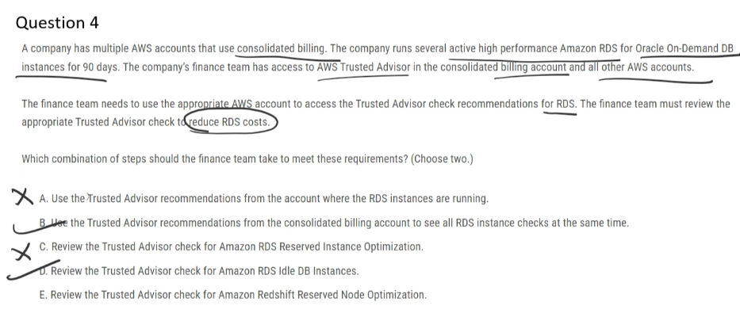

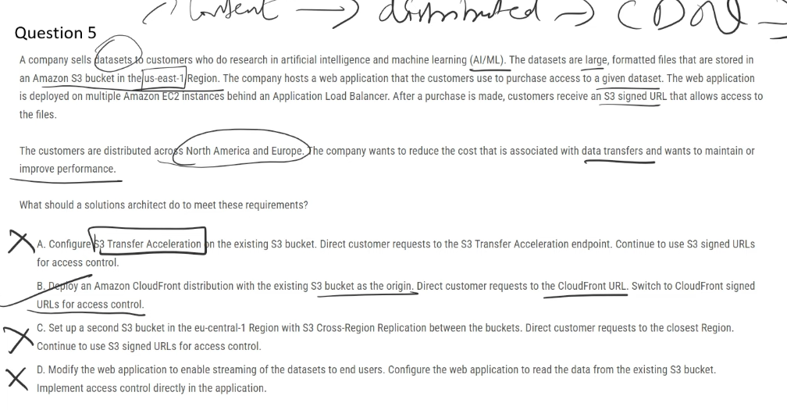

## **✅ Correct Answer: B**

**B. Deploy an Amazon CloudFront distribution with S3 as the origin and use CloudFront signed URLs**  
 CloudFront caches large datasets at edge locations, **reducing S3 data transfer costs** and **improving performance** for users distributed across regions.

## **❌ Incorrect Options**

**A. Configure S3 Transfer Acceleration on the S3 bucket**  
 S3 Transfer Acceleration is optimized for **uploads**, does **not cache content**, and **adds extra cost**, making it unsuitable for cost-efficient global downloads.

**C. Create a second S3 bucket with Cross-Region Replication**  
 CRR increases **storage and replication costs** and still does not provide edge caching, making it less cost-effective than CloudFront.

**D. Stream datasets through the web application**  
 Routing large downloads through EC2 increases **compute and bandwidth costs** and negatively impacts scalability and performance.

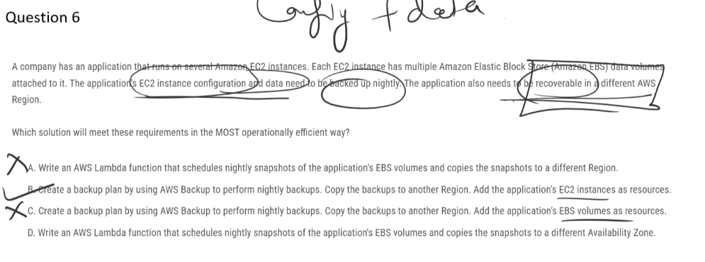

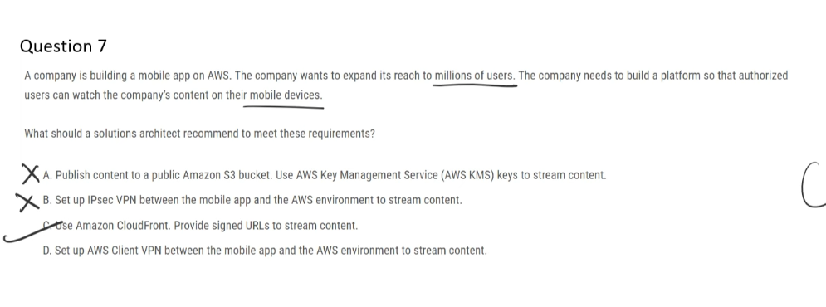

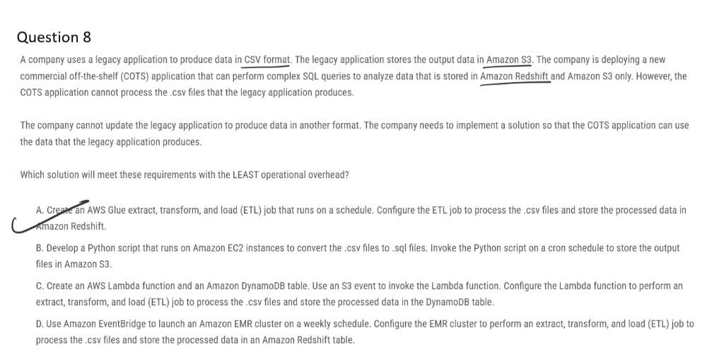

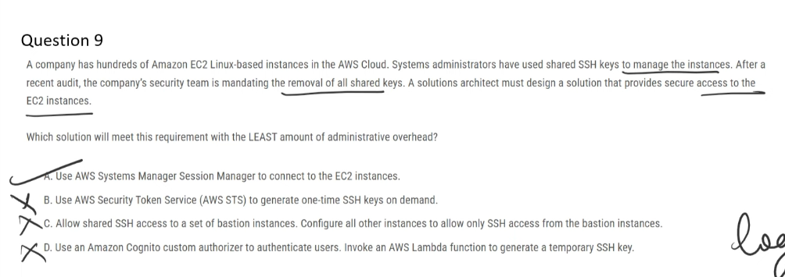

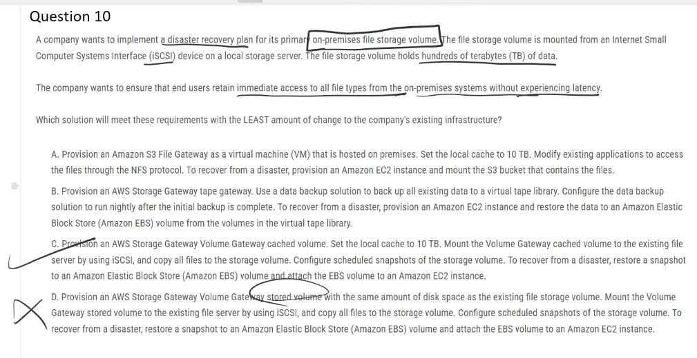

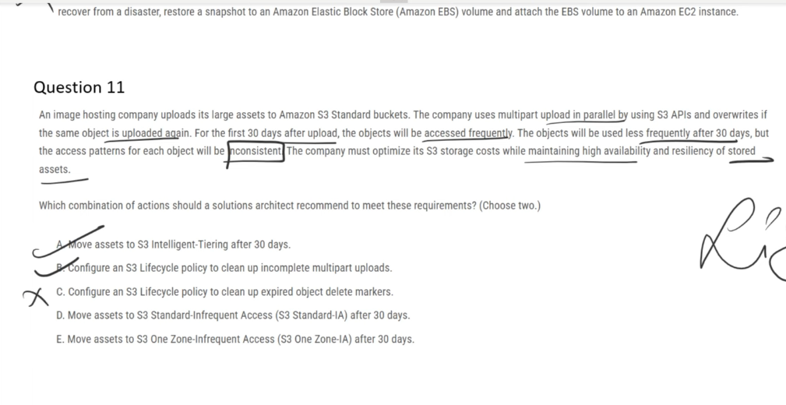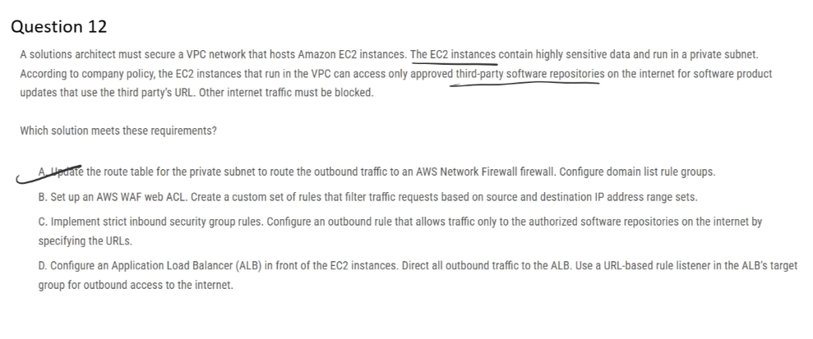

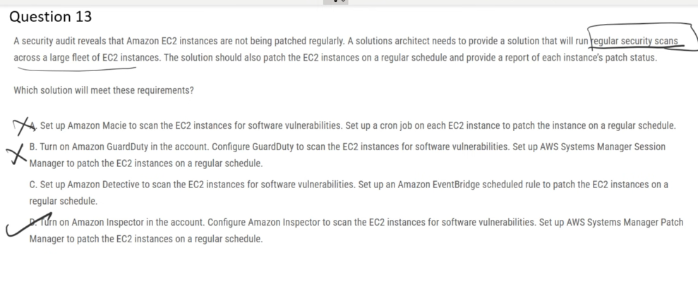

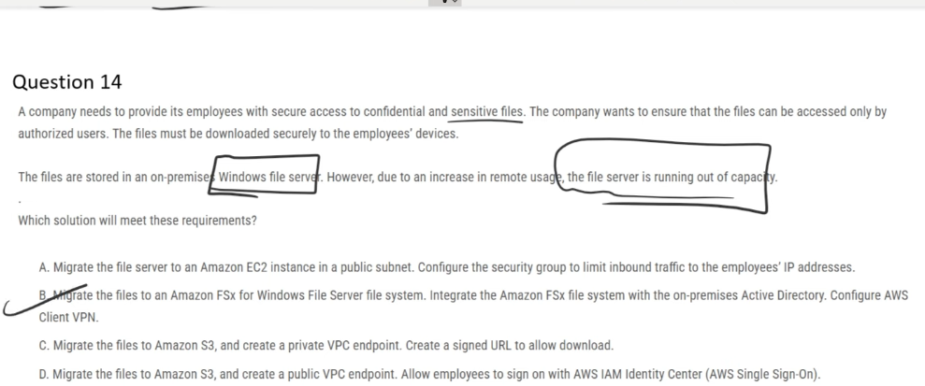

## **✅ Correct Answer: B**

### **Revision-ready explanations (copy-paste)**

### **✅ B. Amazon FSx for Windows File Server + AD + Client VPN**

Provides a **fully managed Windows file system (SMB)** with **Active Directory integration**, preserving NTFS permissions and enabling secure remote access for employees.

### **❌ A. EC2 file server in a public subnet**

Exposes the file server to the internet and creates **security, scalability, and management risks**, making it unsuitable for sensitive enterprise file access.

### **❌ C. Amazon S3 + private VPC endpoint + signed URLs**

S3 is **object storage**, not a Windows file system, and does not support **SMB access, NTFS permissions, or mapped drives**, causing major workflow disruption.

### **❌ D. Amazon S3 + public VPC endpoint + IAM Identity Center**

A **public endpoint** increases exposure risk, and IAM-based access does not replace **Windows file server permissions or SMB-based access**.

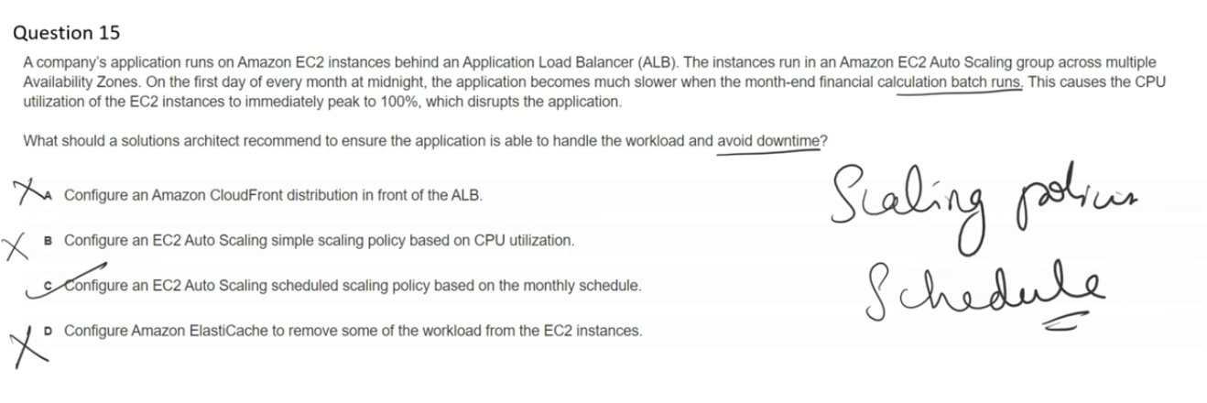

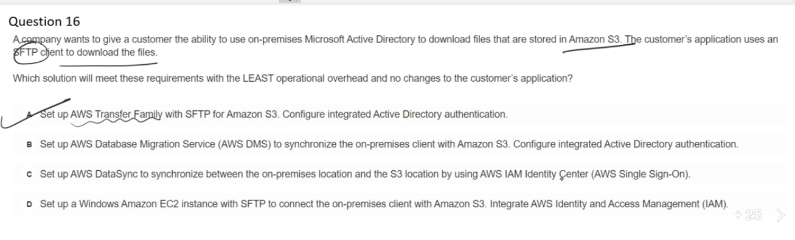

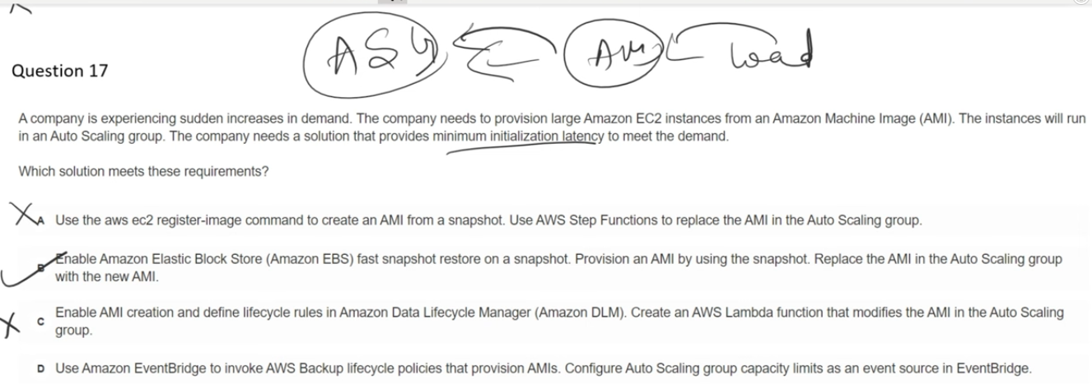

## **✅ Correct Answer: B**

**B. Enable EBS Fast Snapshot Restore on a snapshot and create an AMI from it**  
 Fast Snapshot Restore pre-initializes snapshot data, allowing EC2 instances in Auto Scaling to **launch with minimal startup latency** during sudden demand spikes.

## **❌ Incorrect Options**

**A. Use register-image and Step Functions to replace the AMI**  
 This automates AMI replacement but **does not reduce EC2 boot time**, so initialization latency remains unchanged.

**C. Use Amazon Data Lifecycle Manager (DLM) and Lambda to modify the ASG AMI**  
 DLM manages AMI creation and retention, **not snapshot pre-warming or launch performance**.

**D. Use EventBridge with AWS Backup lifecycle policies**  
 AWS Backup handles backup automation, **not EC2 startup speed or snapshot initialization latency**.

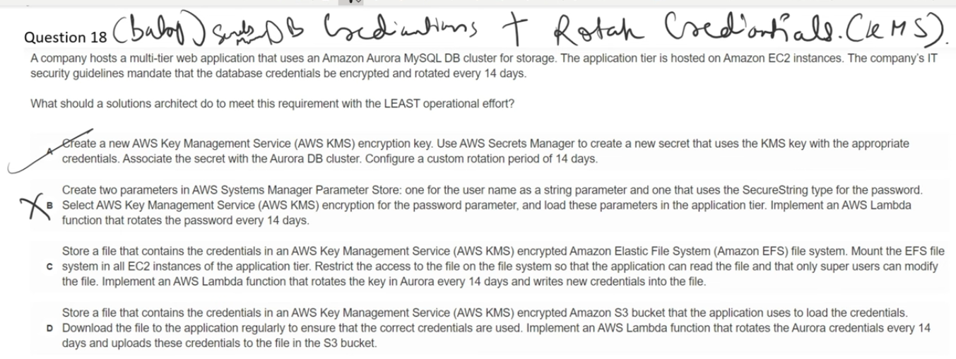

AWS Secrets Manager and AWS Systems Manager Parameter Store are both used to store sensitive data, but they serve different purposes:

AWS Secrets Manager:

* Specifically designed for managing secrets like database credentials, API keys, and OAuth tokens
* Automatic rotation: Built-in capability to automatically rotate secrets on a schedule
* Native integration with RDS databases (MySQL, PostgreSQL, Aurora)
* Custom rotation using Lambda functions for other secret types
* Higher cost but more features for secret lifecycle management

Systems Manager Parameter Store:

* General-purpose hierarchical storage for configuration data and secrets
* Stores data like AMI IDs, license codes, passwords, and database strings
* No automatic rotation: You must manually update parameters
* Lower cost (free tier available for standard parameters)
* Can reference Secrets Manager secrets, allowing you to use secrets stored in Secrets Manager through Parameter Store

When to Use:

* Secrets Manager: When you need automatic rotation, managing database credentials, or full secret lifecycle management
* Parameter Store: For configuration data, static secrets that don't need rotation, or when cost is a concern

Integration: You can store secrets in Secrets Manager and reference them from Parameter Store, combining the rotation capabilities of Secrets Manager with Parameter Store's integration with other AWS services.

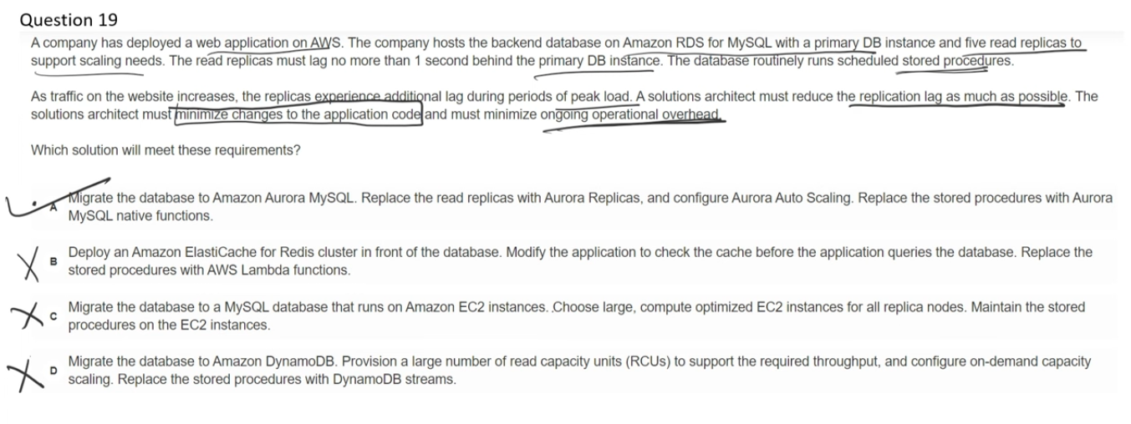

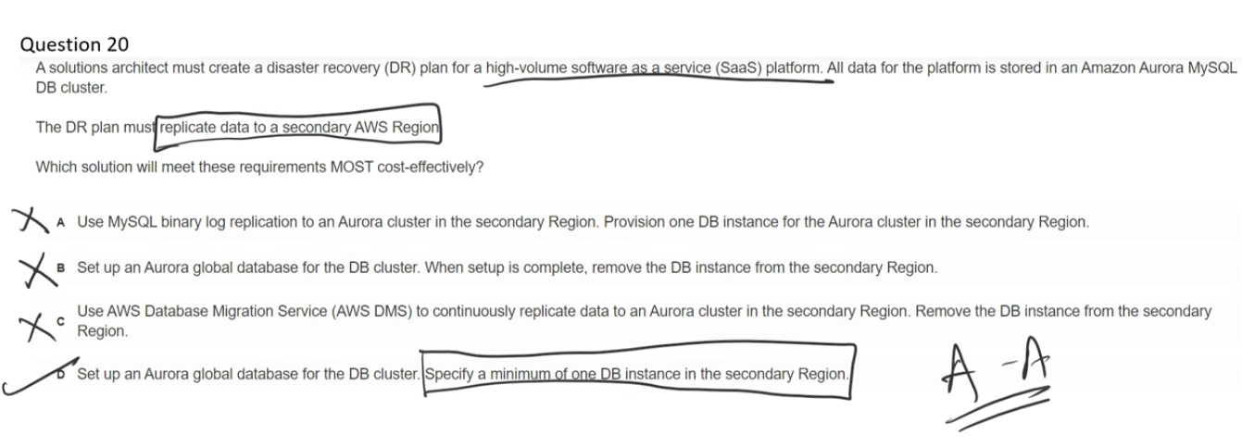

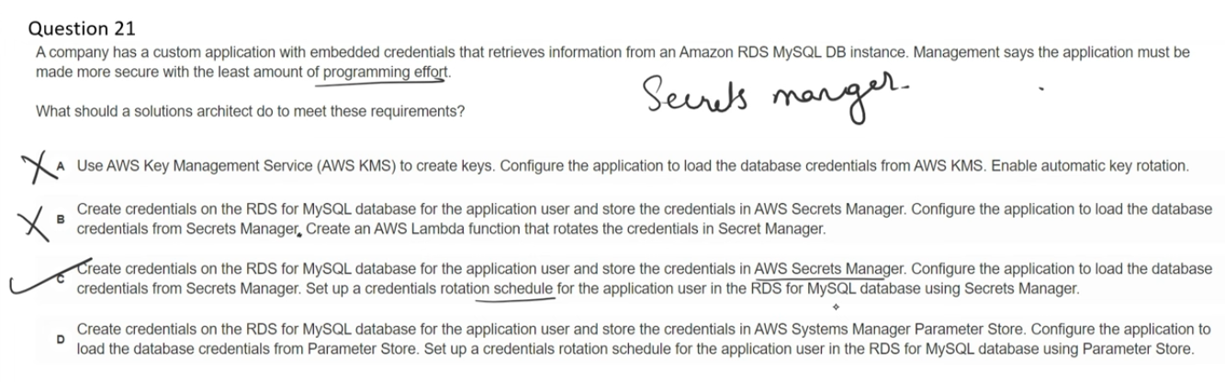

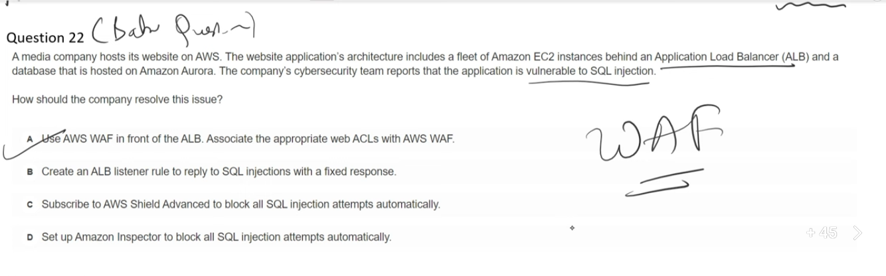

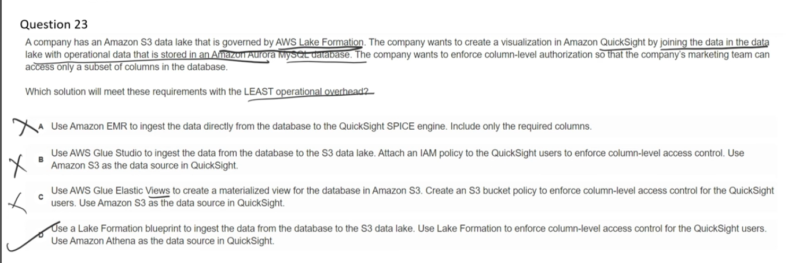

## **Why Athena is the correct data source in Option D**

When QuickSight uses **Athena**:

1. Athena queries tables defined in the **Glue Data Catalog**
2. The catalog is governed by **Lake Formation**
3. Lake Formation enforces:
   1. Table permissions
   2. **Column-level permissions**
4. QuickSight users see **only allowed columns**

👉 This is **native, centralized, low-overhead security**.

## **❌ A. EMR → QuickSight SPICE**

Requires managing EMR clusters and custom ingestion pipelines, resulting in **high operational overhead** and no native Lake Formation governance.

## **❌ B. Glue Studio + IAM policies**

IAM policies **cannot enforce column-level access on data**, and duplicating data into S3 increases complexity and maintenance.

## **❌ C. Glue Elastic Views + S3 bucket policy**

S3 bucket policies do **not support column-level authorization**, and Elastic Views add unnecessary complexity.

## **✅ D. Lake Formation + Athena + QuickSight**

Lake Formation natively enforces **column-level permissions**, Athena applies those permissions at query time, and QuickSight integrates directly with Athena with **minimal operational overhead**.

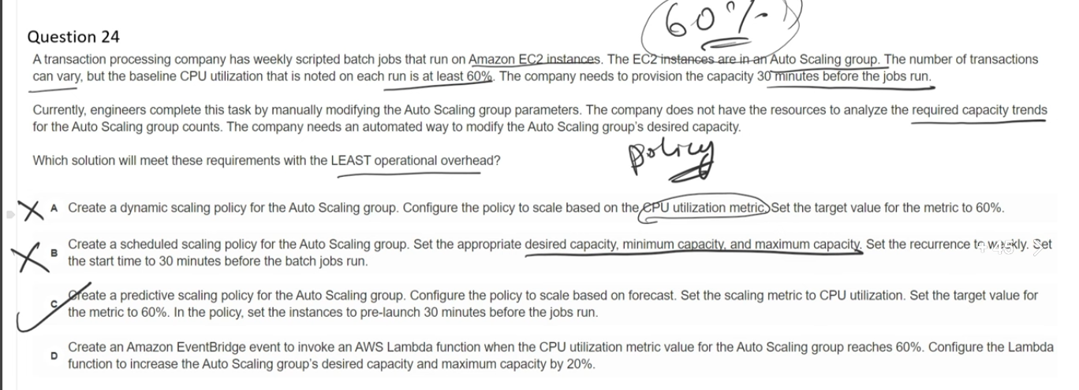

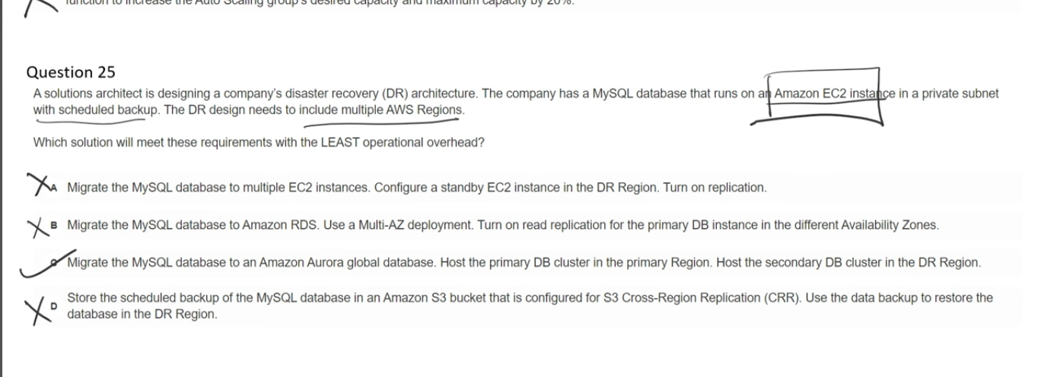

### **❌ A. MySQL on multiple EC2 instances with replication**

Requires managing EC2, MySQL replication, patching, and failover manually, resulting in **high operational overhead**.

### **❌ B. Amazon RDS Multi-AZ with read replicas**

Multi-AZ and read replicas are **within a single Region**, so this does **not satisfy multi-Region DR**.

### **✅ C. Amazon Aurora Global Database**

Provides **managed, low-latency cross-Region replication** with minimal operational effort, making it the **lowest-overhead DR solution**.

### **❌ D. Backups to S3 with Cross-Region Replication**

Requires **manual restore and reconfiguration during disaster recovery**, leading to higher RTO and operational overhead.

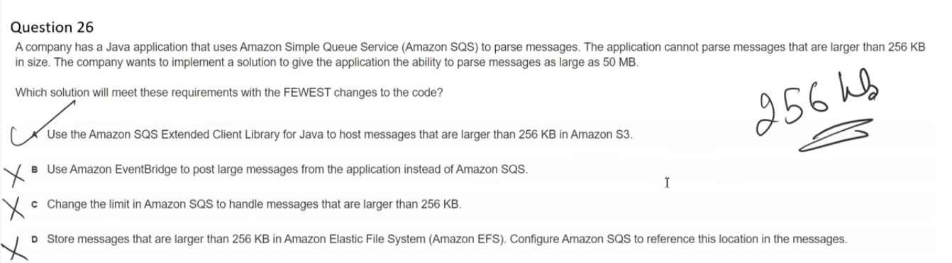

The maximum message size that Amazon SQS can accept is 256 KB (262,144 bytes). The minimum message size is 1 byte (1 character).

For messages larger than 256 KB:

You can use the [Amazon SQS Extended Client Library for Java](https://github.com/awslabs/amazon-sqs-java-extended-client-lib)  or [Python](https://github.com/awslabs/amazon-sqs-python-extended-client-lib) . This library allows you to:

* Send an SQS message that contains a reference to a message payload stored in Amazon S3
* Support payloads up to 2 GB in size
* The actual SQS message contains only a pointer to the S3 object

Note: The extended client libraries work only for synchronous clients.

How to configure:

You can set the maximum message size using the MaximumMessageSize attribute in the SQS console or via the SetQueueAttributes API method, with values between 1,024 bytes (1 KB) and 262,144 bytes (256 KB).

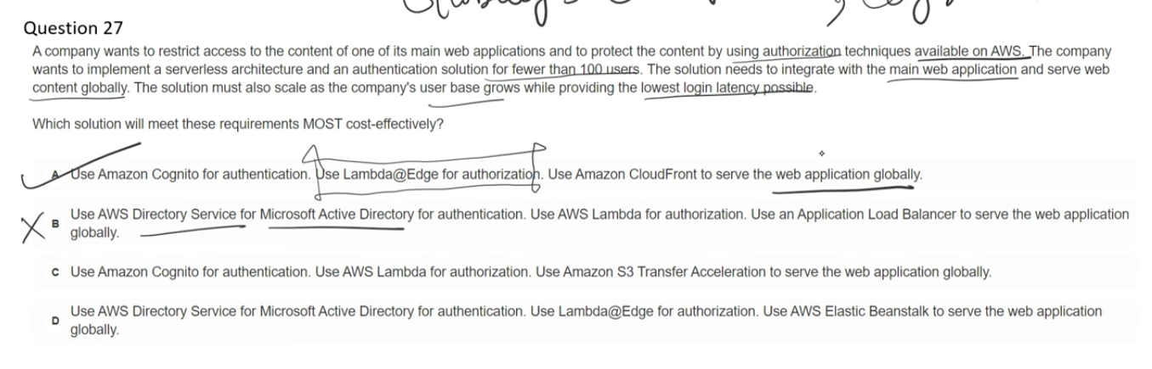

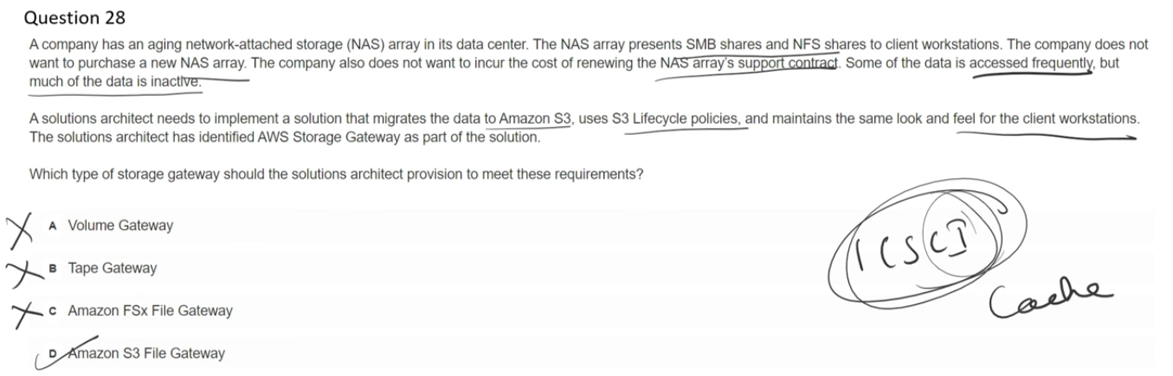

Amazon S3 File Gateway:

* Stores files as objects in Amazon S3
* Provides NFS or SMB access to S3 buckets
* Optimized for large files and scale-out workloads
* Best for: Database backups, archives, data lakes, machine-generated data, and ingesting vast amounts of data into S3
* Can contain billions of objects

Amazon FSx File Gateway:

* Provides low-latency, on-premises access to Amazon FSx for Windows File Server
* Optimized for small and mixed file size workloads
* Best for: Multi-user interactive file sharing, departmental shares, home directories, and end-user applications like Microsoft Office
* Supports complex Windows features like permissions, data deduplication, and DFS Namespaces

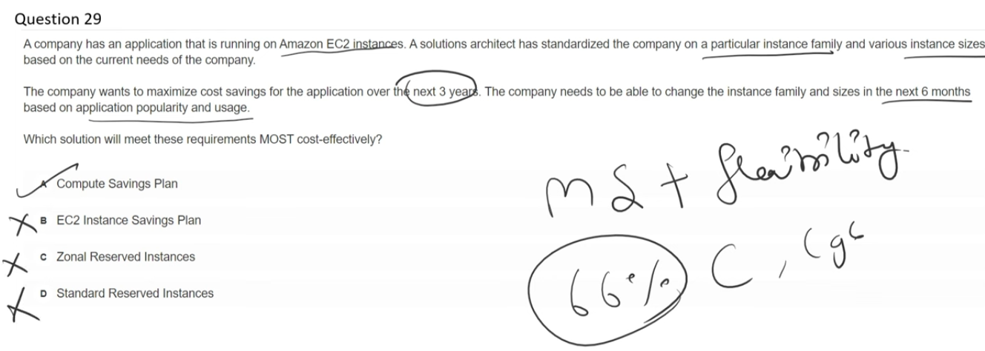

**In which are the plan, is it possible to change the EC2 instance family?**

You can change EC2 instance families in the following plans:

1. Compute Savings Plans:

* Provides the most flexibility to change instance families
* You can switch between any instance family (e.g., C4 to M5, M6i to C5)
* Works across any Region, OS, tenancy, and even applies to Fargate and Lambda
* Offers up to 66% savings

2. EC2 Instance Savings Plans:

* Cannot change instance families - locked to a specific instance family within a Region
* You can only change instance sizes within the same family (e.g., c5.xlarge to c5.2xlarge)
* Can change OS (Windows to Linux) and tenancy within the same family
* Offers up to 72% savings (highest discount)

3. Reserved Instances (RIs):

* Standard RIs: Cannot change instance family
* Convertible RIs: Can change instance family, but with some restrictions and potentially lower discount rates
* Can modify Linux/UNIX RIs within the same instance family

Summary: Only Compute Savings Plans offer full flexibility to change between different instance families. EC2 Instance Savings Plans and Standard RIs lock you to a specific instance family.

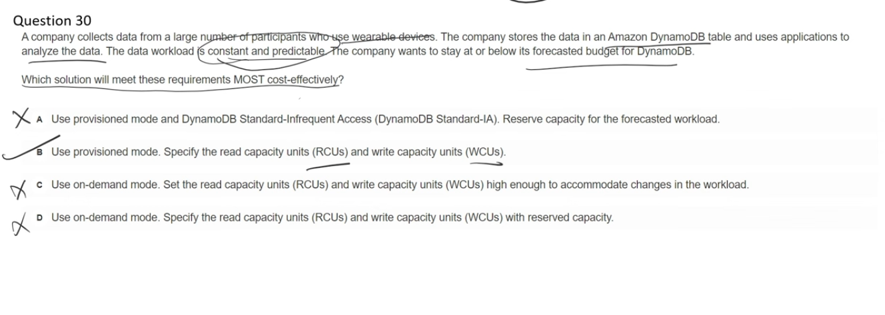

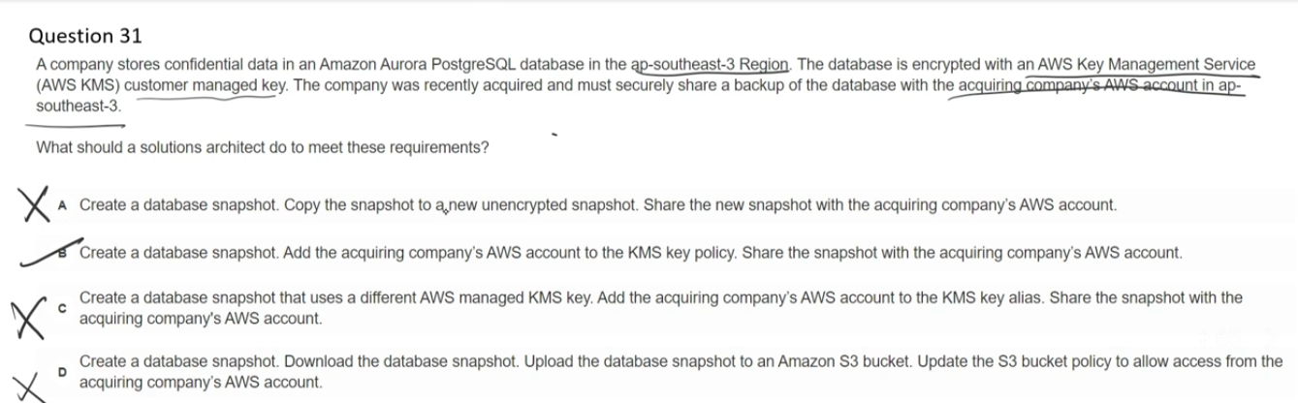

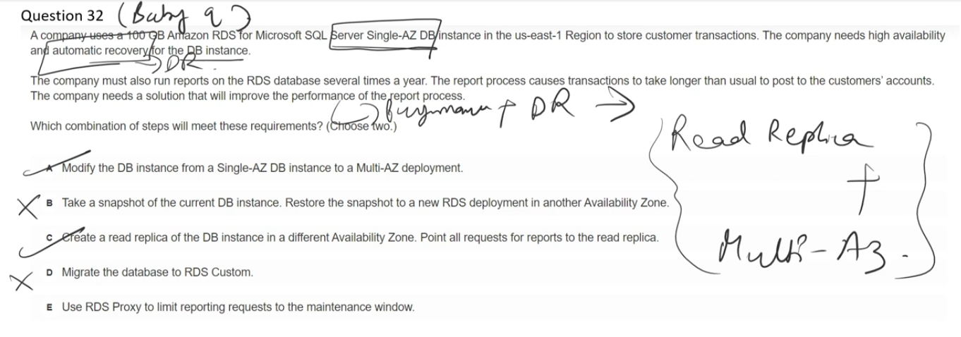

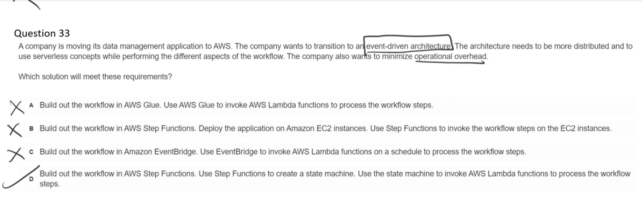

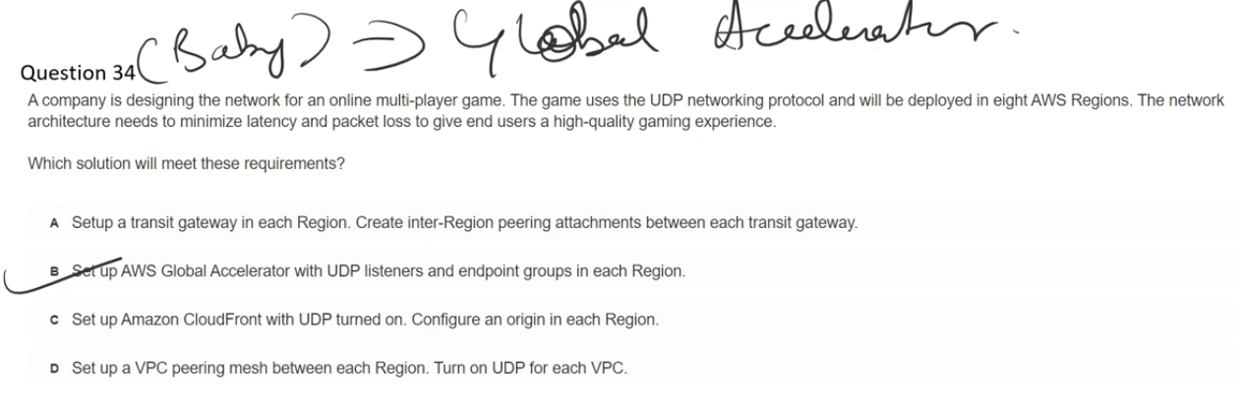

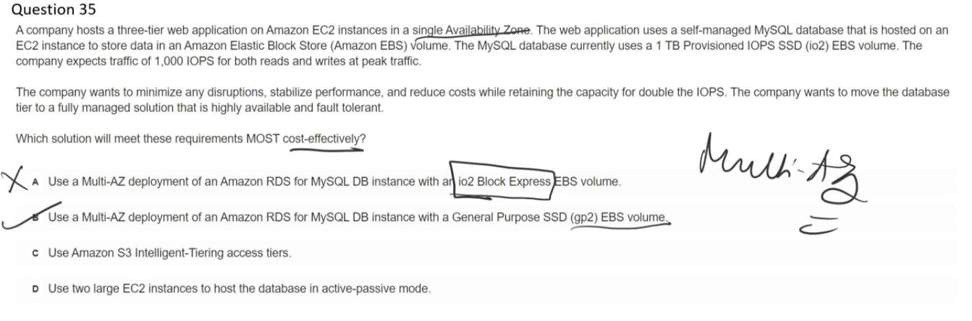

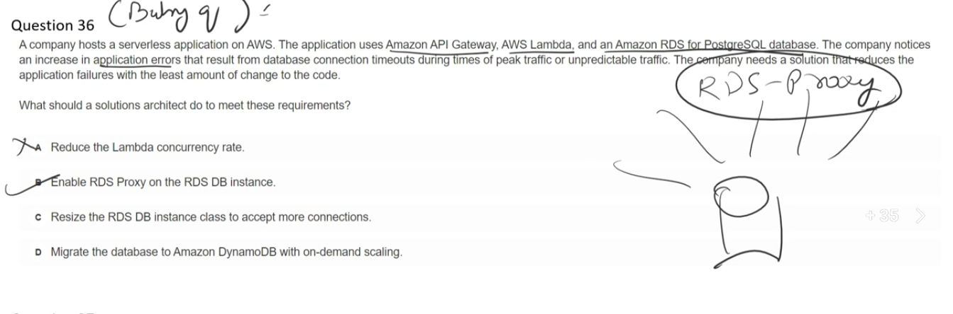

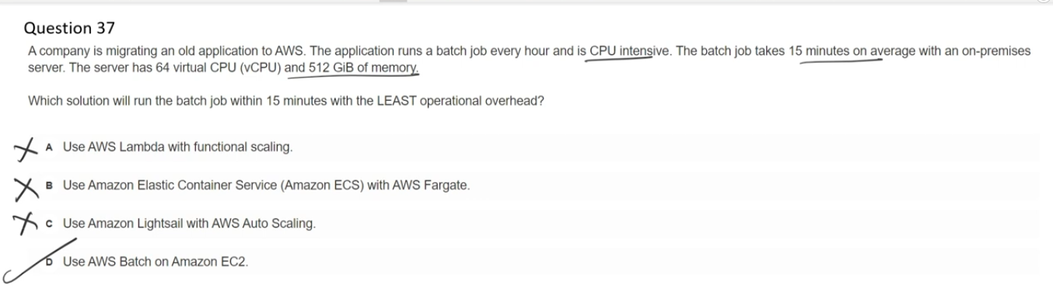

**For the AWS Batch service, dont we need to choose the ec2 instance type?**

No, you don't necessarily need to choose a specific EC2 instance type for AWS Batch. AWS Batch offers flexible options:

Automatic Instance Selection:

You can let AWS Batch automatically select the best instance types by choosing:

* optimal: Selects from C4, M4, R4, C5, M5, and R5 instance families (Note: Starting 11/01/2025, this will behave like default_x86_64)
* default_x86_64: Chooses x86-based instances (M6i, C6i, R6i, C7i) that match your job queue demands
* default_arm64: Chooses ARM-based instances (M6g, C6g, R6g, C7g) that match your job queue demands

Manual Instance Selection:

You can also specify exact instance types if needed:

* Specific instance families (e.g., c5, p3)
* Specific instance sizes (e.g., c5.8xlarge)

How It Works: When you create a Compute Environment, you set parameters like minimum, desired, and maximum vCPUs. AWS Batch then efficiently launches, manages, and terminates instances based on your job queue demands and the instance type selection you've configured. This flexibility allows you to optimize for cost and performance without manually managing instance selection.

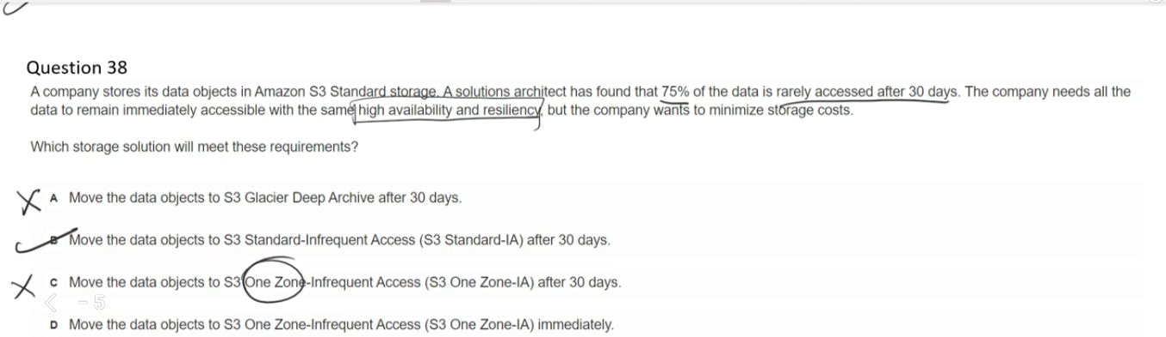

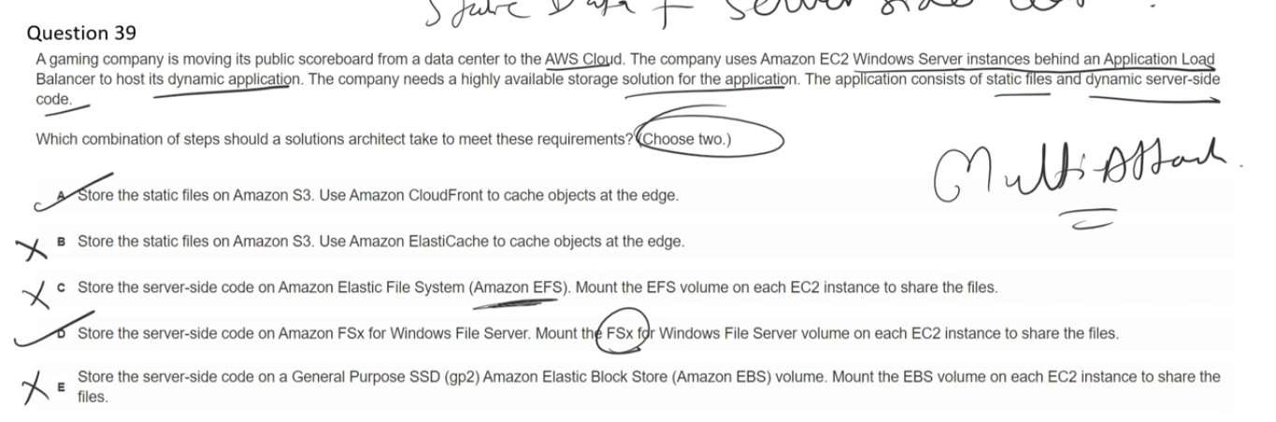

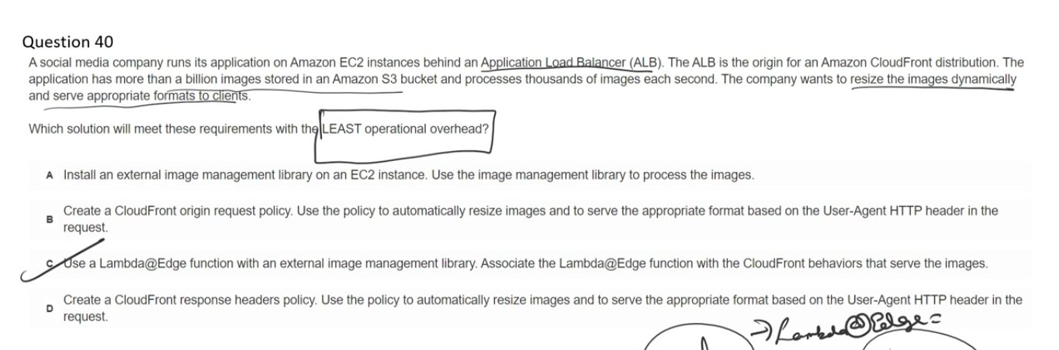

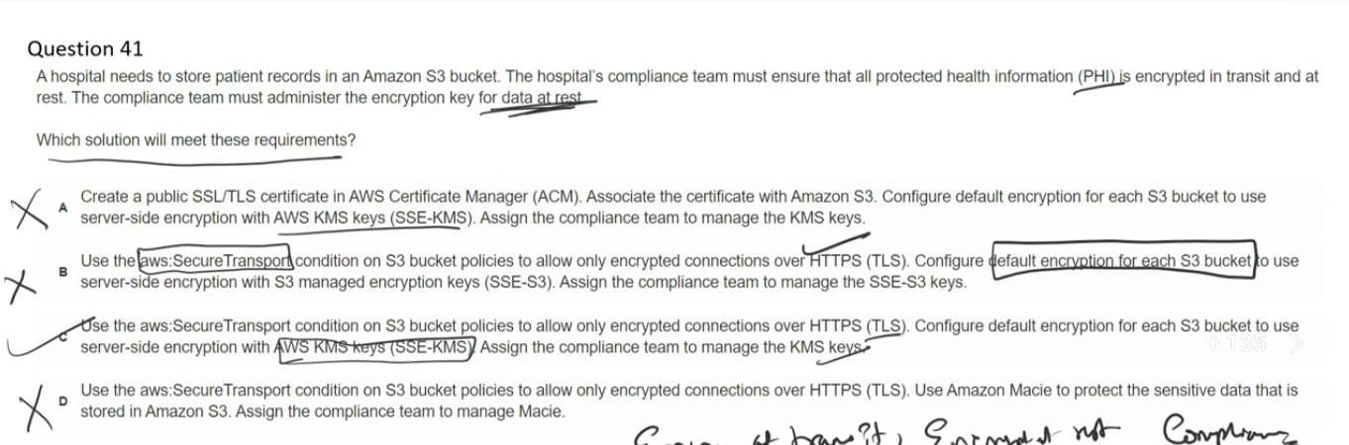

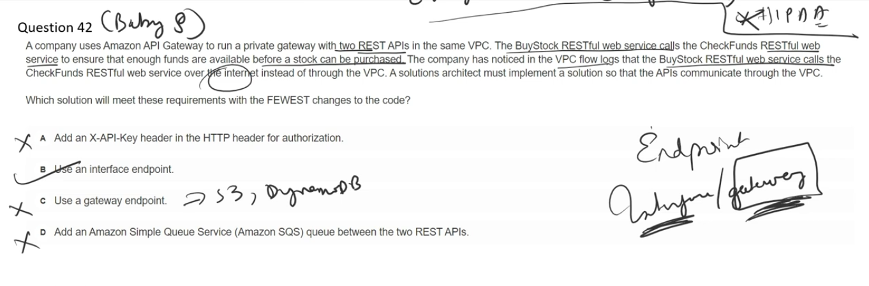

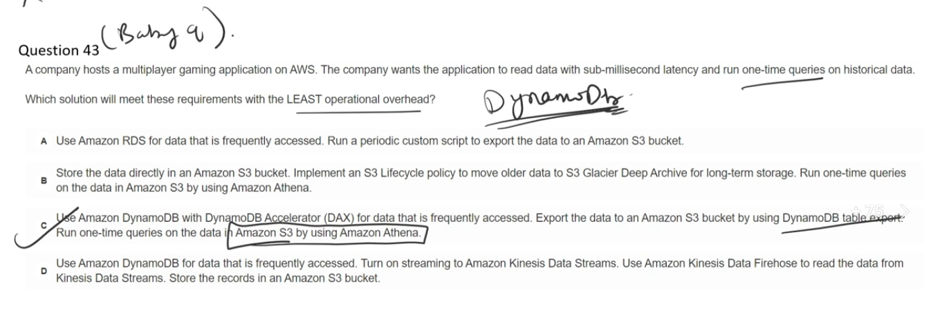

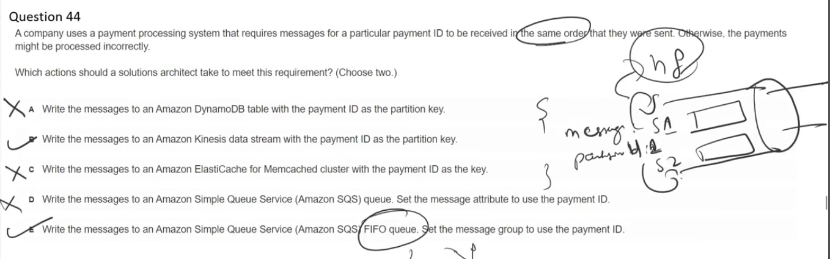

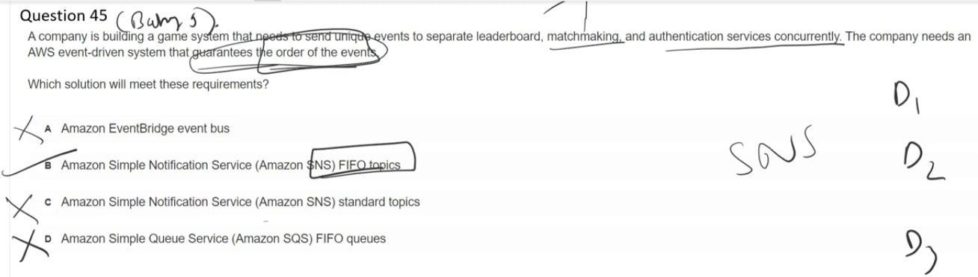

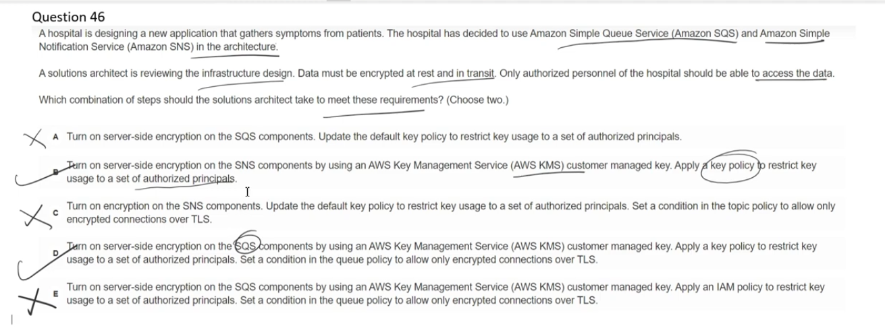

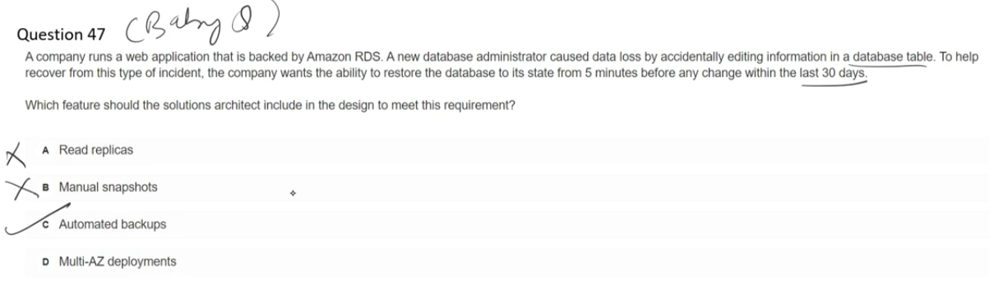

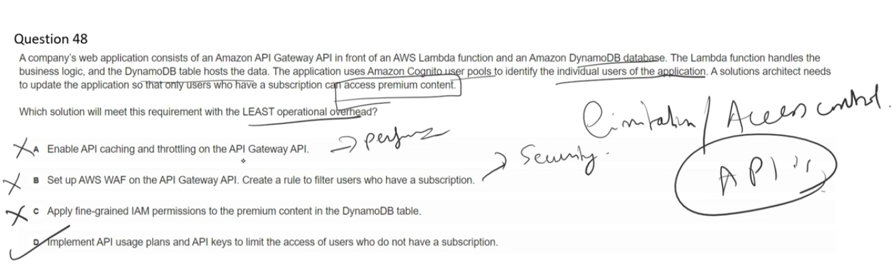

API Gateway Usage Plans allow you to control and monetize access to your APIs. They specify who can access your deployed API stages and methods, and how much and how fast they can access them.

Key Features:

* Throttling: Control request rates (average requests per second) and burst capacity to prevent overwhelming downstream resources
* Quota: Set limits on the number of requests per day, week, or month
* API Keys: Distribute alphanumeric keys to customers to grant access and track usage per key

Common Use Cases:

1. Monetization: Create tiered offerings (Bronze, Silver, Gold) with different access levels and pricing
2. Rate Limiting: Protect backend services from excessive requests
3. Customer Segmentation: Different plans for Student, Individual, Professional, or Enterprise users
4. Access Control: Manage which API stages (test, beta, production) each customer can access

How It Works:

You create usage plans with specific throttling and quota limits, then associate API keys with these plans. Each API key identifies a customer and enforces the limits defined in their usage plan. This allows you to build ecosystems around your APIs while maintaining control over access and usage.

Usage plans are particularly useful when you want to offer your APIs as product offerings to external developers or partners.

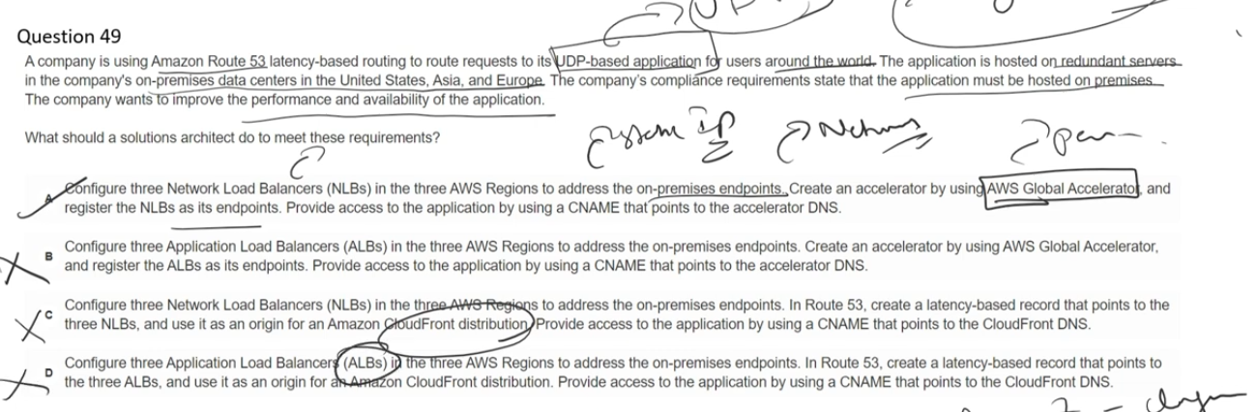

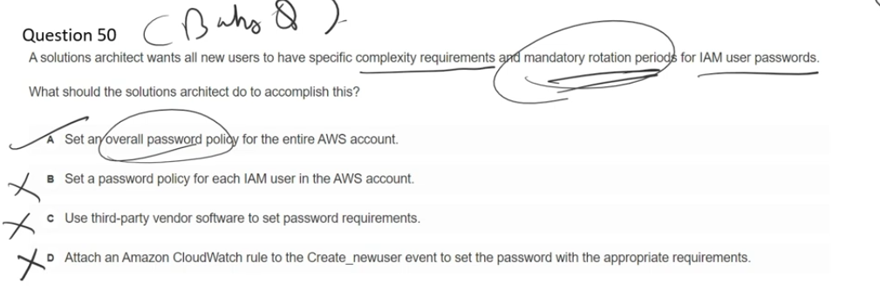

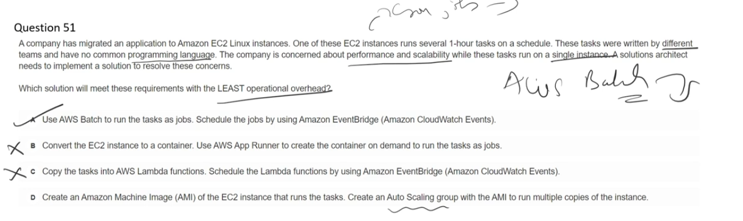

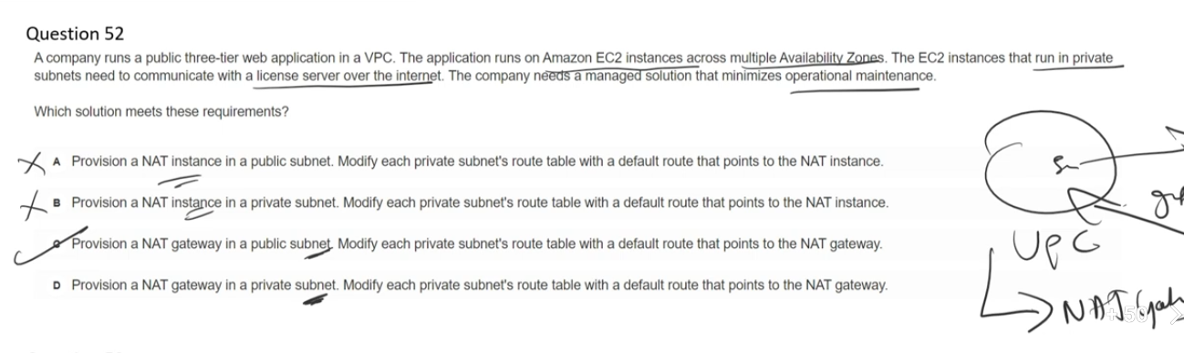

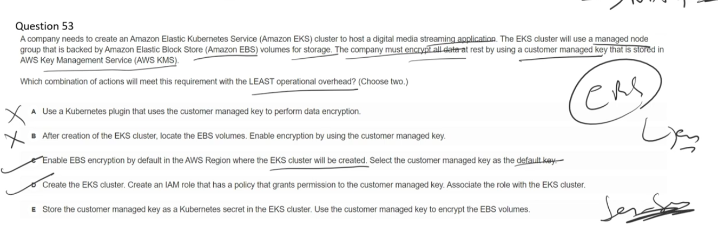

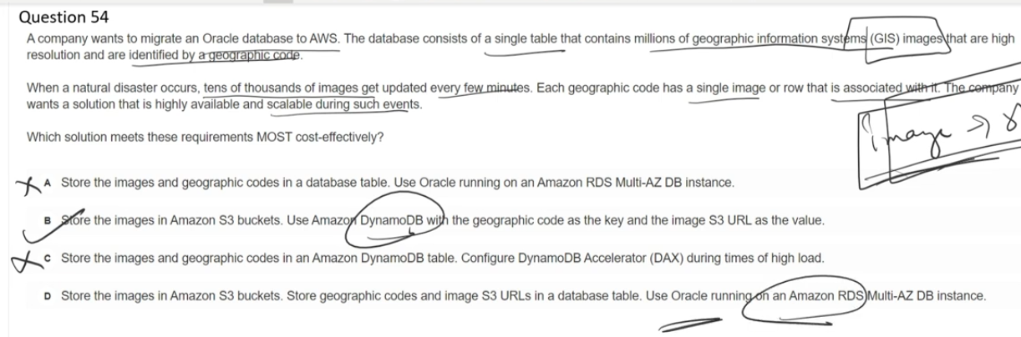

### **❌ A. Images + codes in Oracle RDS (Multi-AZ)**

RDS is not designed for **massive, bursty write scaling** of large objects; Multi-AZ improves availability, not throughput.

### **✅ B. Images in S3 + DynamoDB (geo code → S3 URL)**

S3 provides **cheap, scalable object storage**, and DynamoDB **auto-scales high-throughput key-based writes**, making it the most cost-effective.

### **❌ C. Images + codes in DynamoDB with DAX**

DAX accelerates **reads only**; it does **nothing for write-heavy workloads**, which is the core requirement here.

### **❌ D. Images in S3 + Oracle RDS (Multi-AZ) for metadata**

RDS becomes a **write bottleneck** and is **costly to scale** for sudden, extreme update rates.

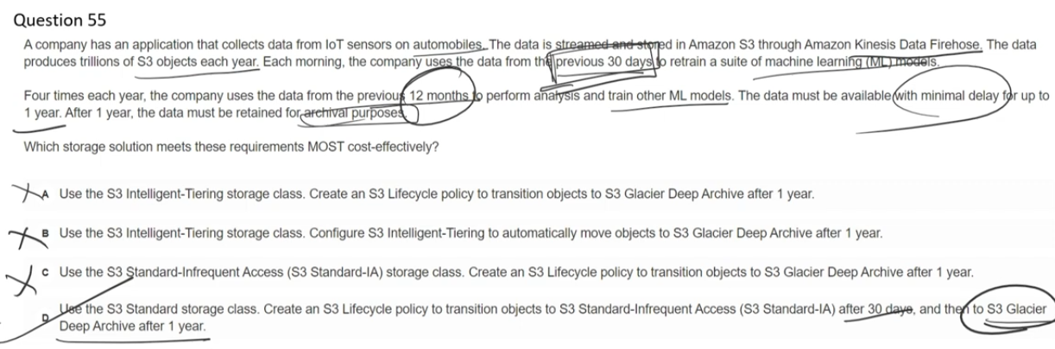

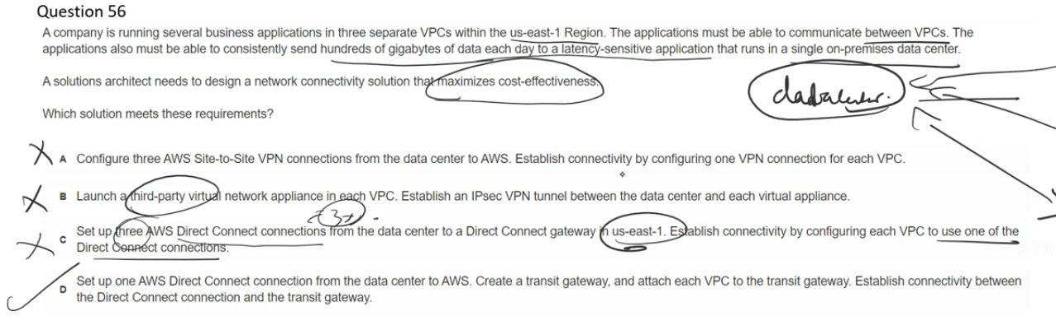

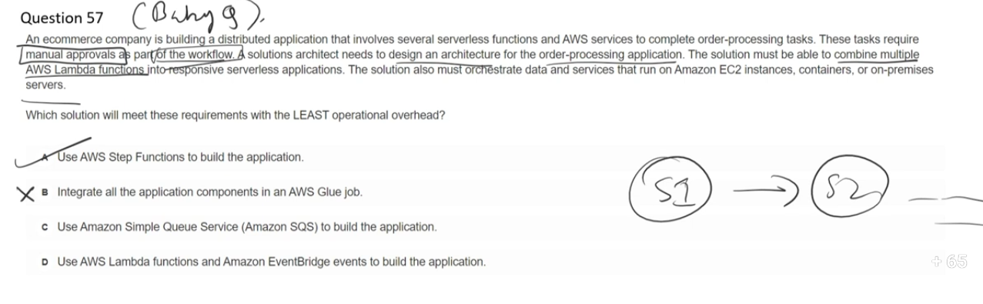

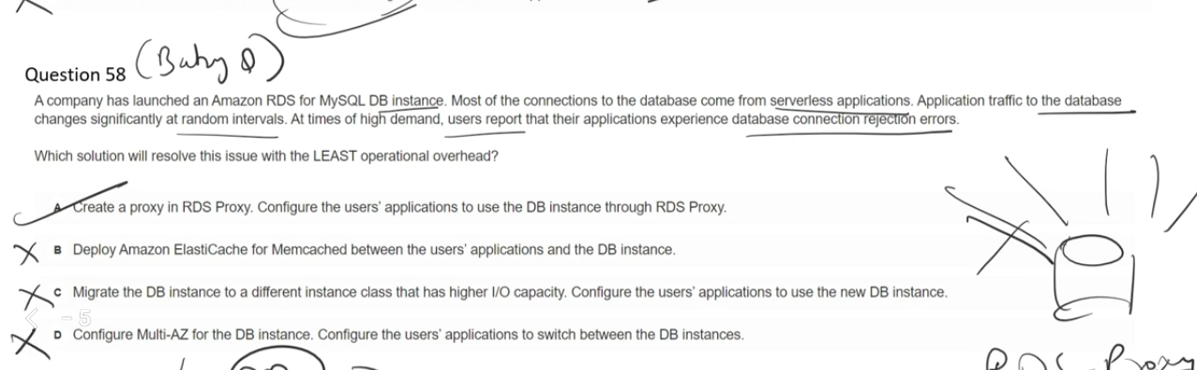

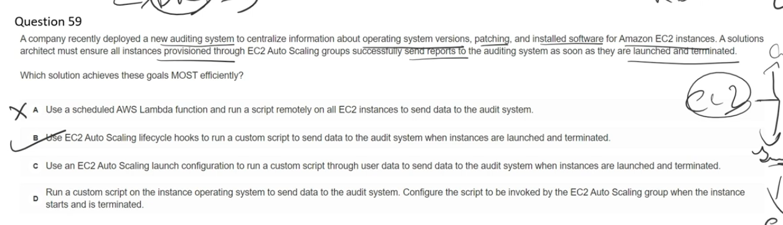

Auto Scaling lifecycle hooks and EC2 user data serve different purposes and offer distinct advantages: EC2 User Data:

* Runs only once when an instance is first launched
* Executes during the boot process
* Cannot pause the instance lifecycle
* No built-in notification or coordination mechanism
* Limited to initialization tasks

Auto Scaling Lifecycle Hooks:

* Provide control at specific points in the instance lifecycle (launch and termination)
* Pause instances in a wait state (default 1 hour) before they become operational or are terminated
* Allow time for custom actions to complete before transitioning to the next state
* Enable event-driven architectures through Amazon EventBridge notifications
* Can send completion signals when tasks finish

Key Advantages of Lifecycle Hooks:

1. Graceful Shutdown: Pause instances before termination to download logs, backup data, or deregister from external systems
2. Validation: Ensure instances are fully configured and ready before receiving traffic
3. Coordination: Integrate with external systems through EventBridge for complex workflows
4. Flexibility: Extend or abandon the lifecycle action based on custom logic
5. Load Balancer Integration: Delay registration until software installation and configuration are complete

When to Use Lifecycle Hooks: Use them when you need guaranteed completion of tasks, graceful termination handling, or integration with event-driven workflows beyond basic initialization.

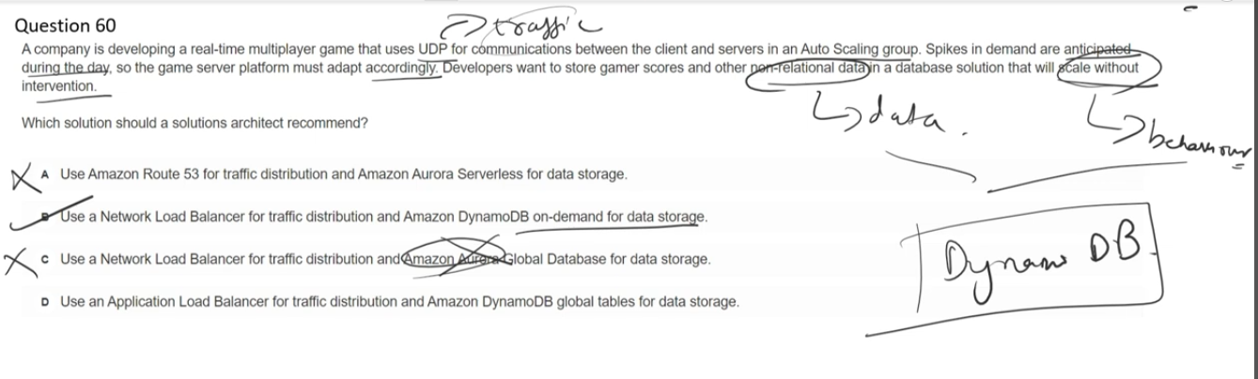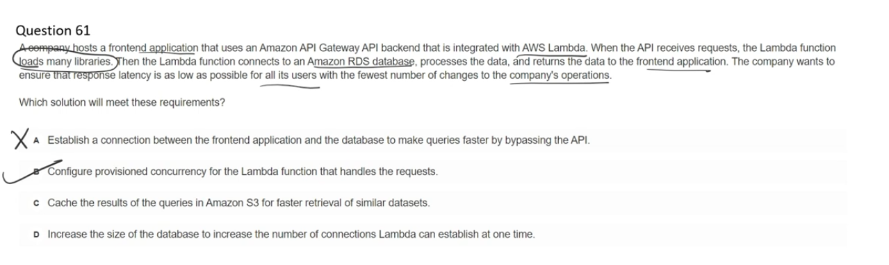

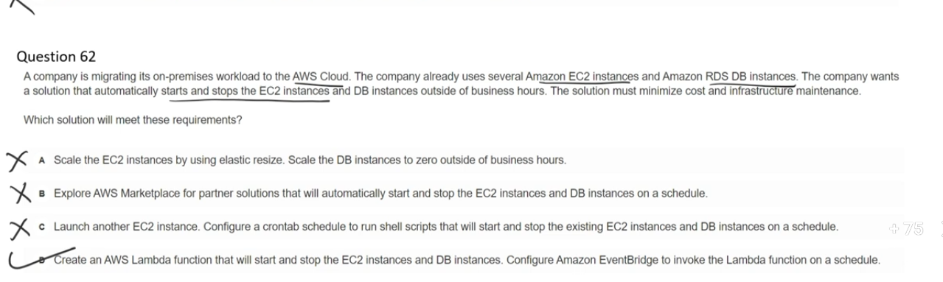

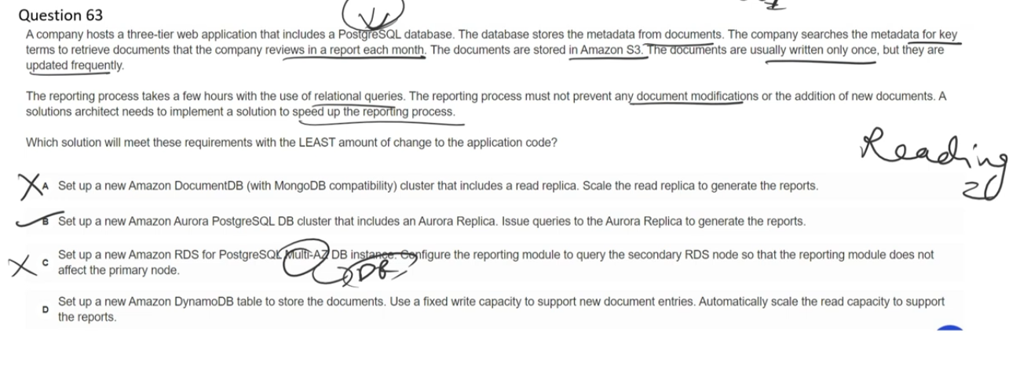

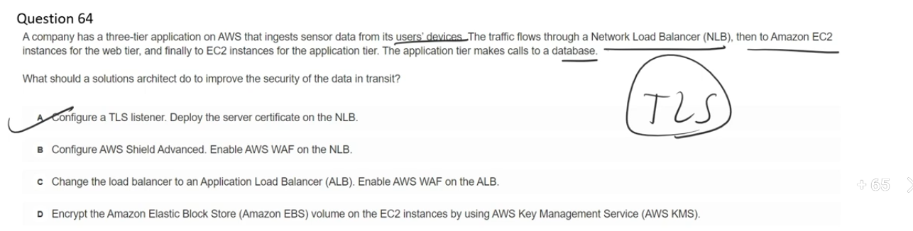

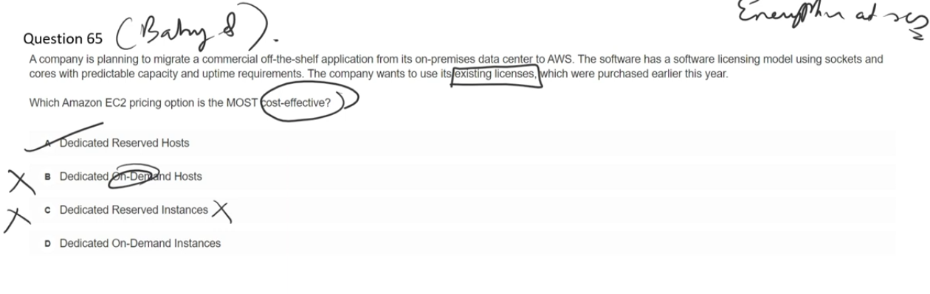Dedicated Reserved Hosts allow you to reserve physical servers fully dedicated to your use for a 1-year or 3-year term, providing significant cost savings (up to 70%) compared to On-Demand Dedicated Hosts.

Key Uses:

* License Compliance: Bring Your Own License (BYOL) for software bound to physical cores, sockets, or VMs (Windows Server, SQL Server, SUSE Linux, Red Hat Enterprise Linux)
* Cost Optimization: Reduce costs through commitment-based pricing with All Upfront, Partial Upfront, or No Upfront payment options
* Visibility & Control: Full visibility into sockets and physical cores for compliance requirements
* Regulatory Requirements: Meet compliance needs requiring single-tenant hardware

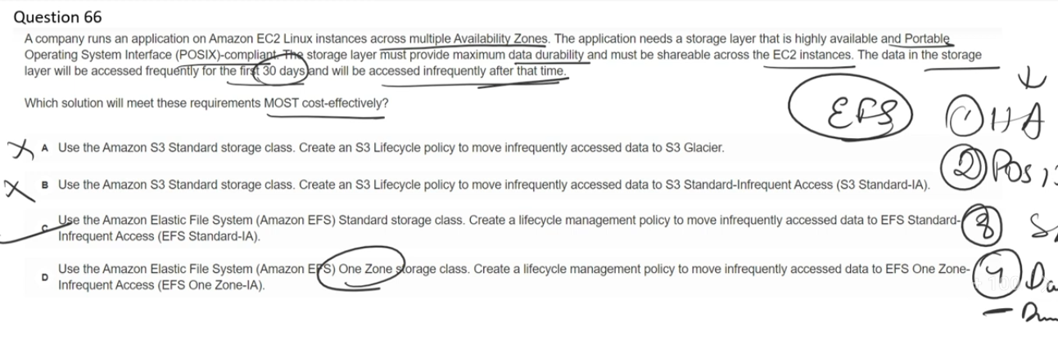

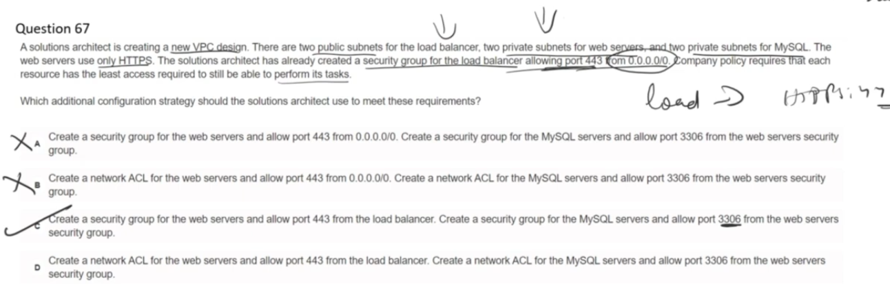

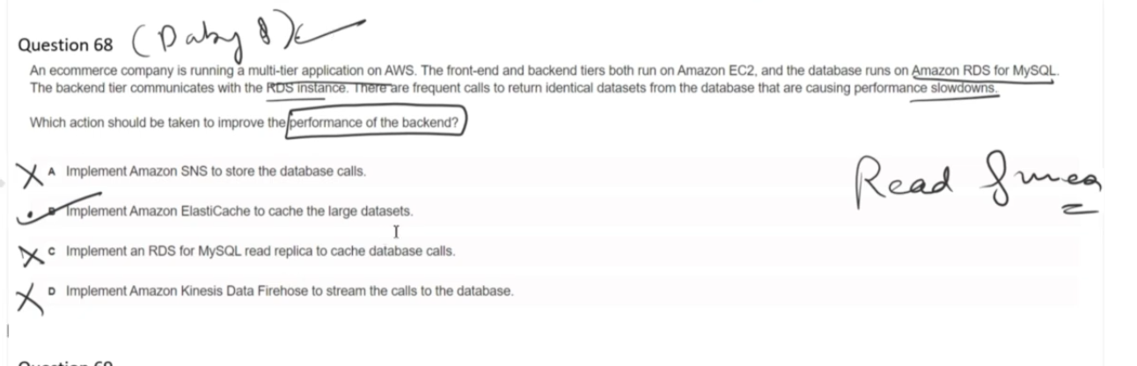

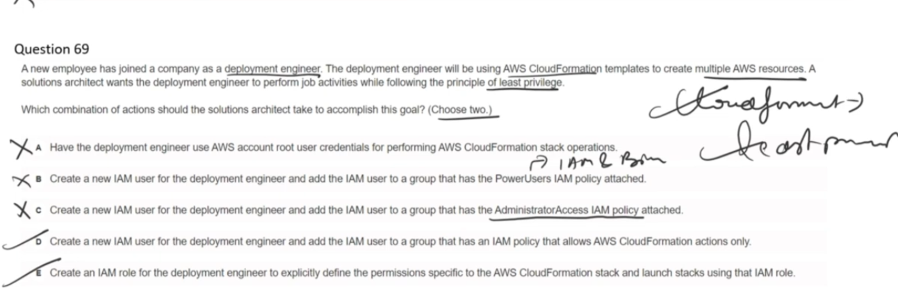

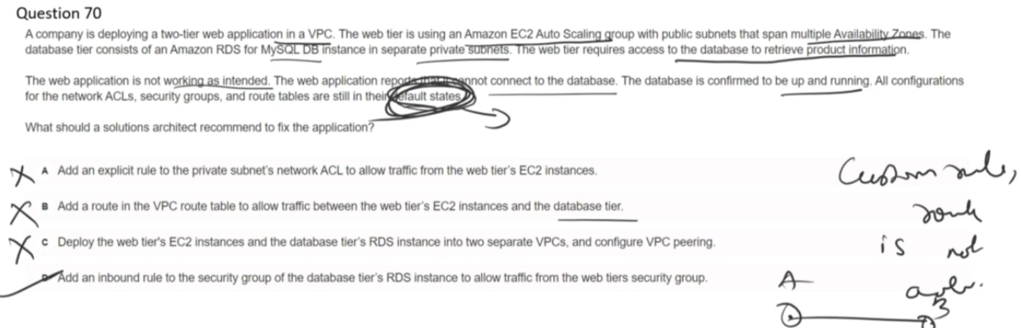

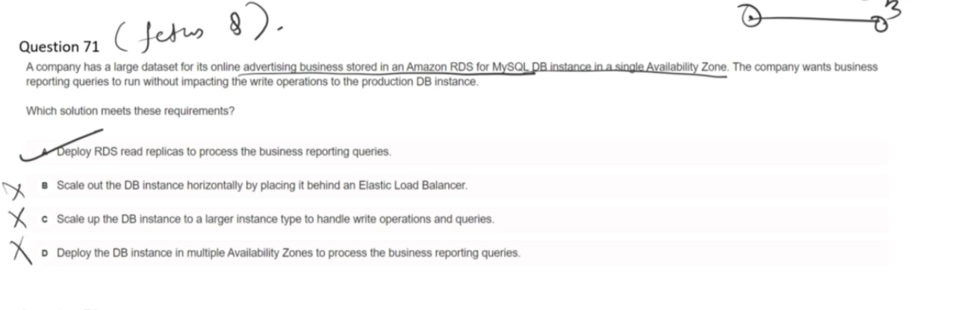

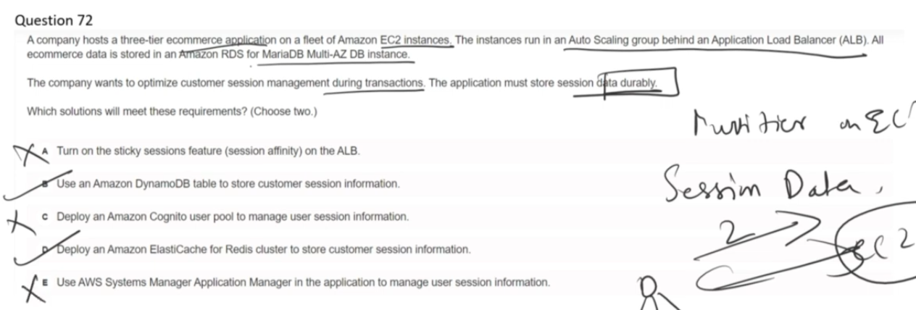

## **5️⃣ Why DynamoDB and ElastiCache Redis ARE correct**

### **✅ DynamoDB**

* Fully managed
* Durable (data replicated across AZs)
* Scales automatically
* Perfect for session key-value data

### **✅ ElastiCache for Redis**

* Extremely low latency
* Shared across EC2 instances
* Industry-standard for session storage
* Can be configured with replication and persistence

These two are the **only services designed for this job**.

## **7️⃣ Now — 1–2 line explanations for ALL options (revision format)**

### **❌ A. Enable sticky sessions on the ALB**

Sticky sessions only control request routing and **do not store session data durably**, so sessions can be lost during failures.

### **✅ B. Use Amazon DynamoDB for session storage**

DynamoDB provides **durable, highly available, shared storage** that scales automatically and survives EC2 failures.

### **❌ C. Use Amazon Cognito**

Cognito manages **authentication and user identity**, not application session state during transactions.

### **✅ D. Use Amazon ElastiCache for Redis**

Redis provides **low-latency, shared session storage** across EC2 instances and is a standard solution for session management.

### **❌ E. Use AWS Systems Manager Application Manager**

Application Manager tracks application metadata and health, **not user session data**.

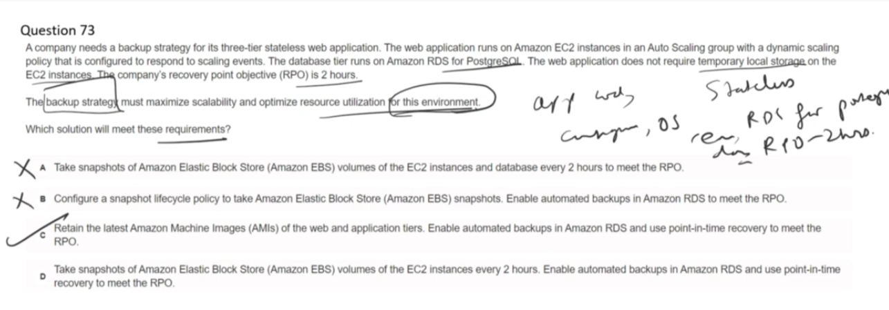

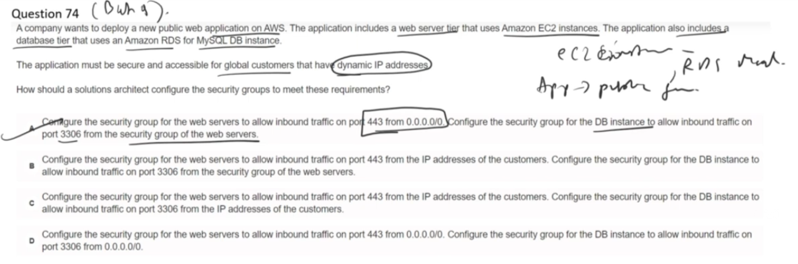

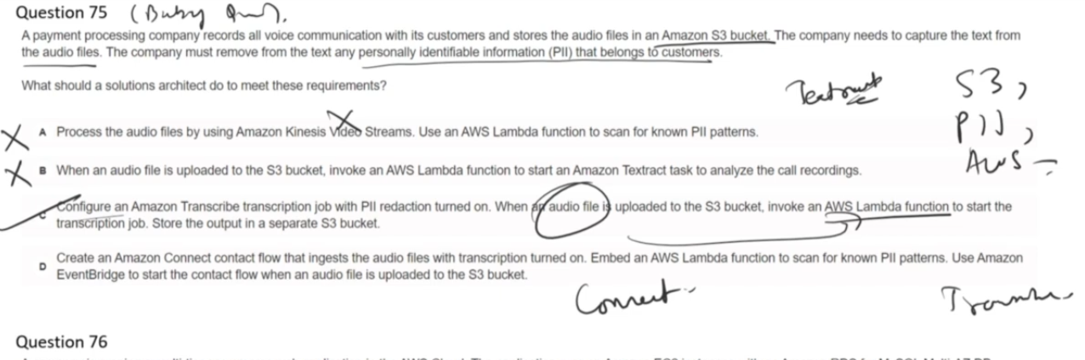

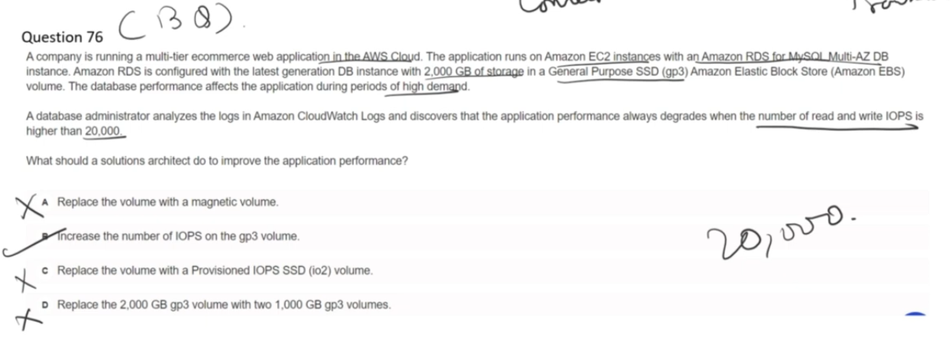

Option C is correct.

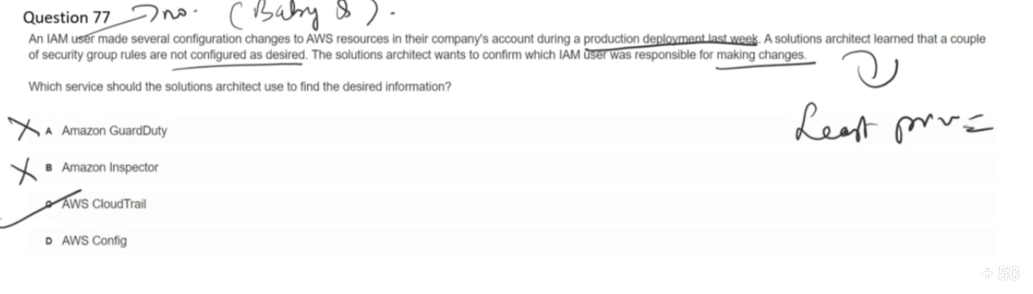

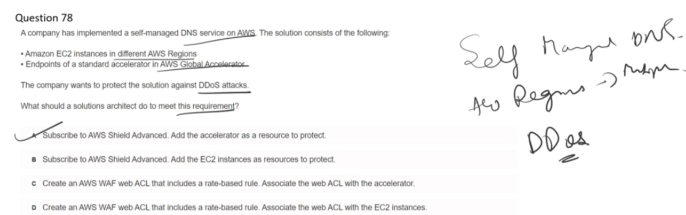

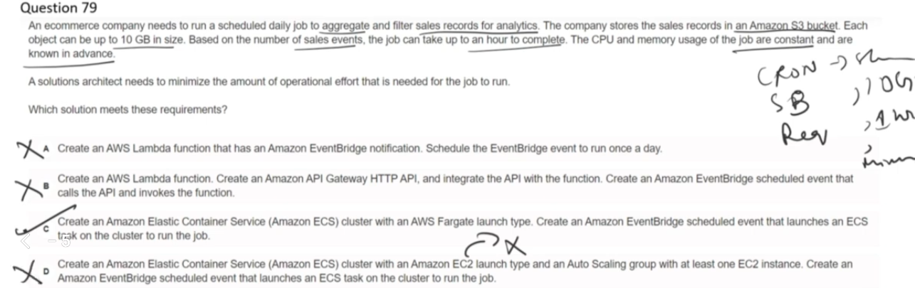In ECS Fargate launch type, we need mention the VCPU's we need. but we wont select any instance names.

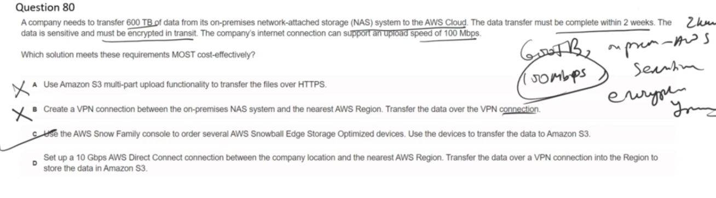

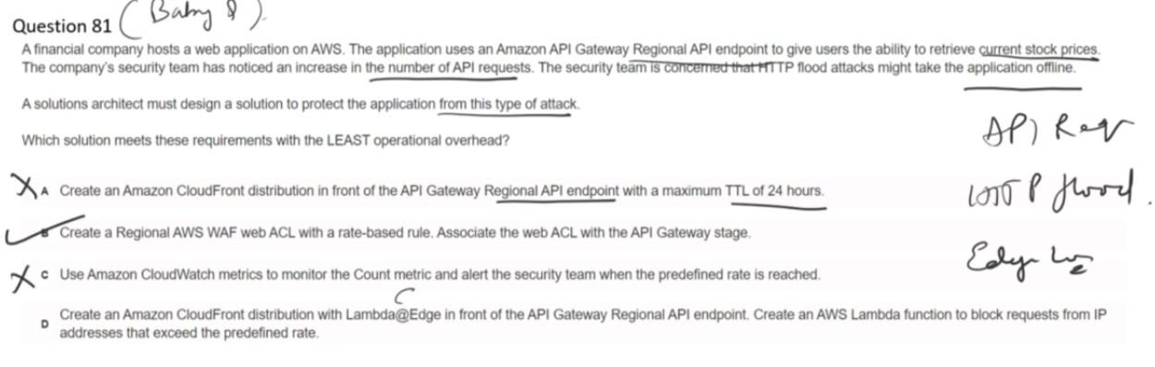

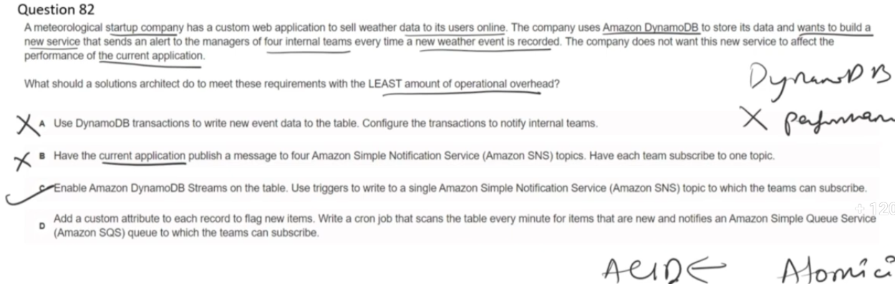

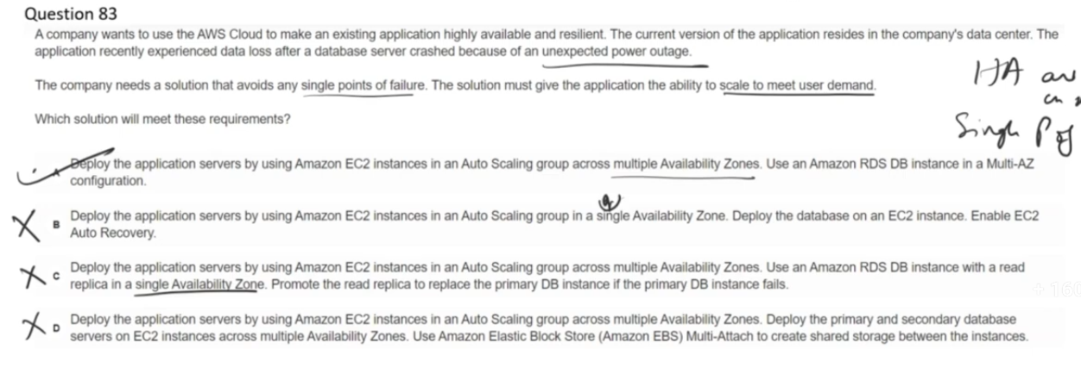

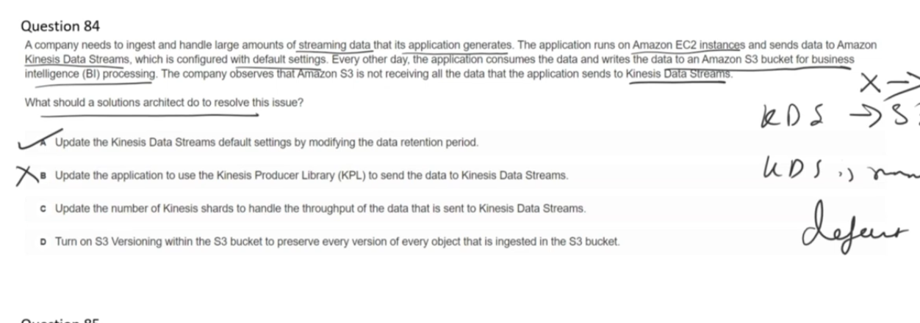

Kinesis data streams default data retention period is 24 hours.

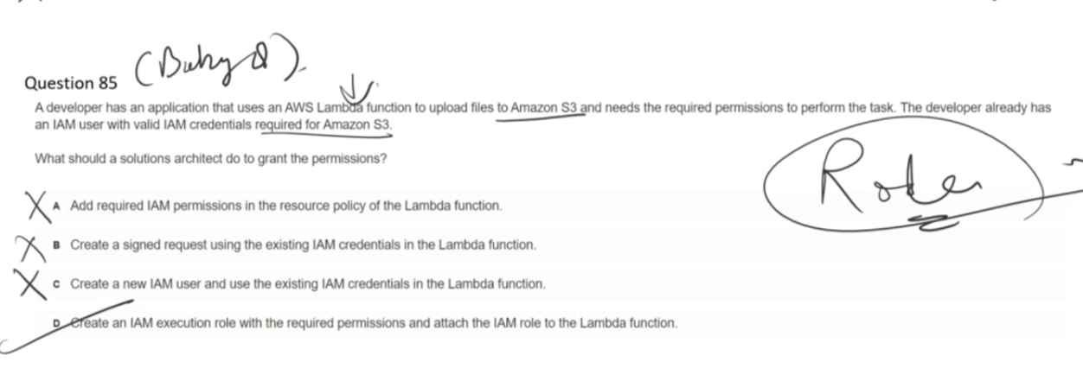

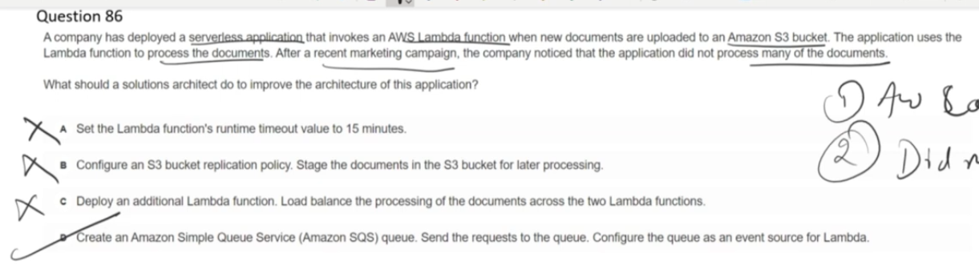

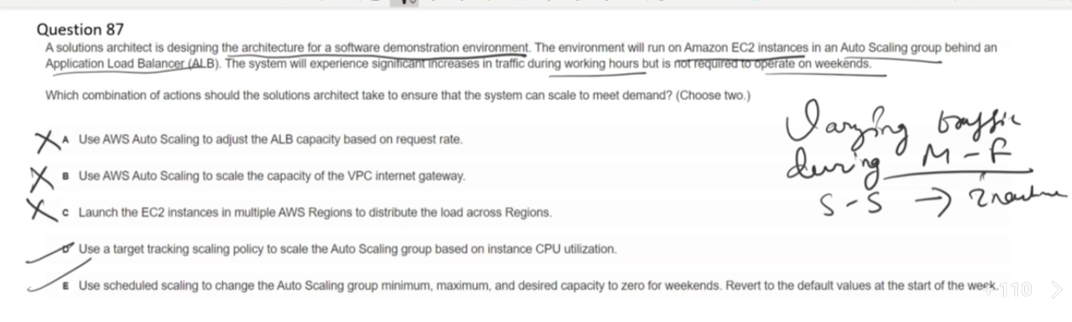

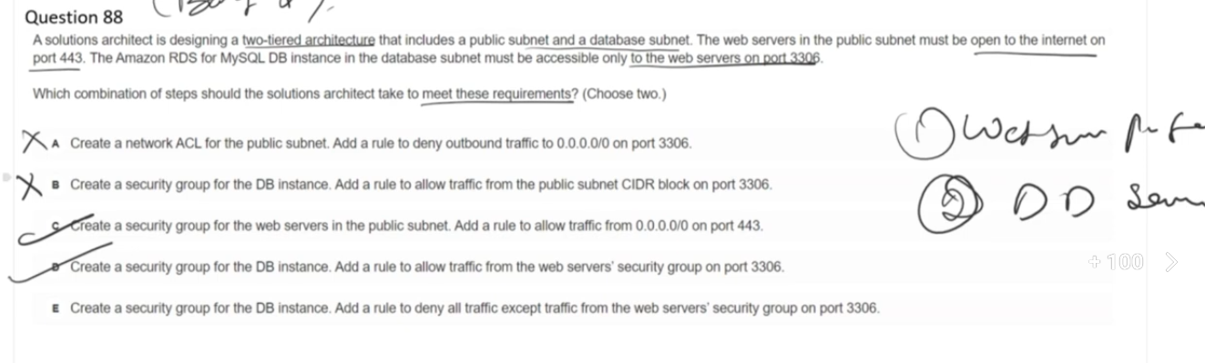

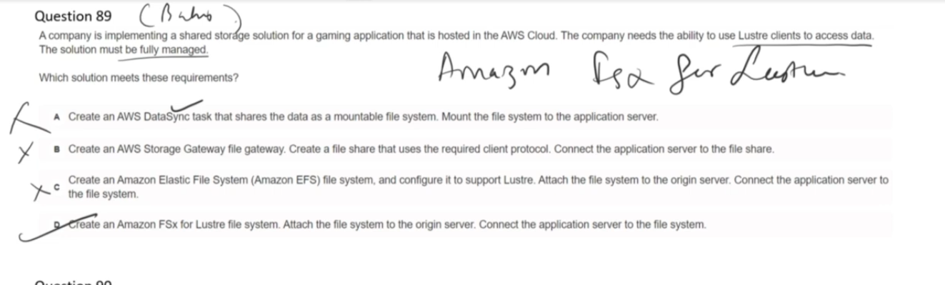

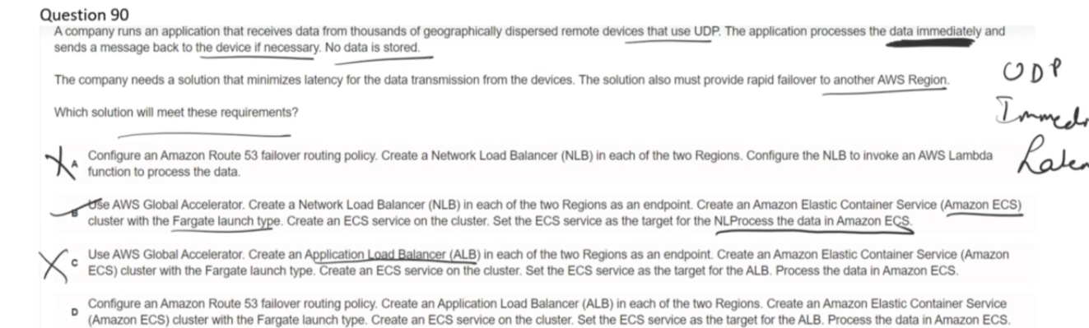

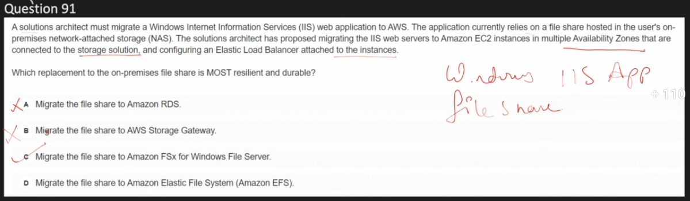

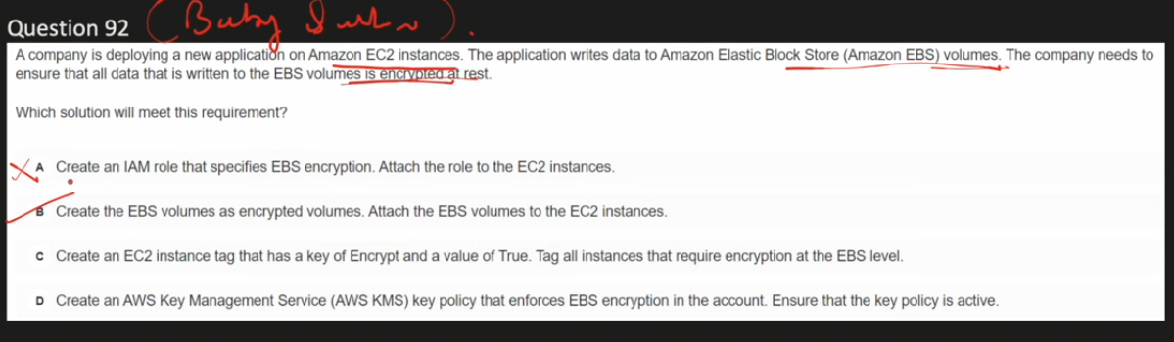

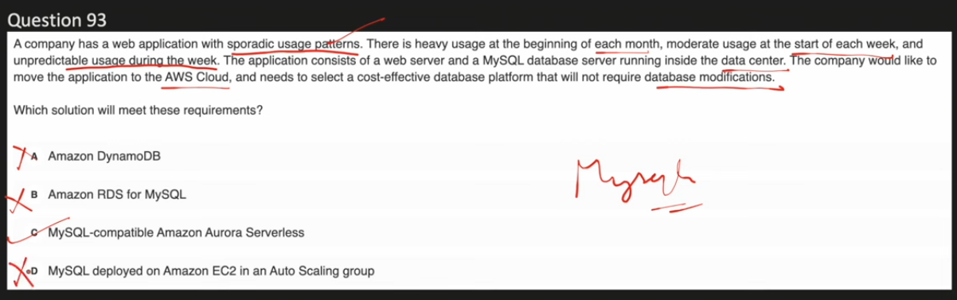

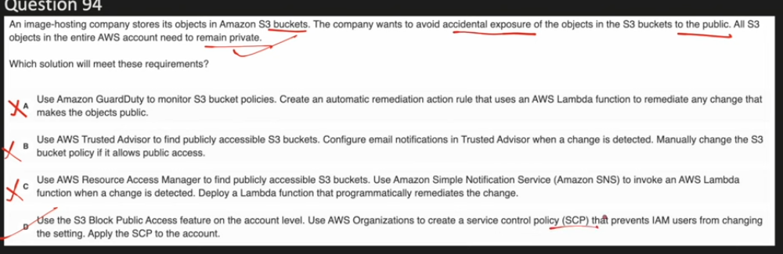

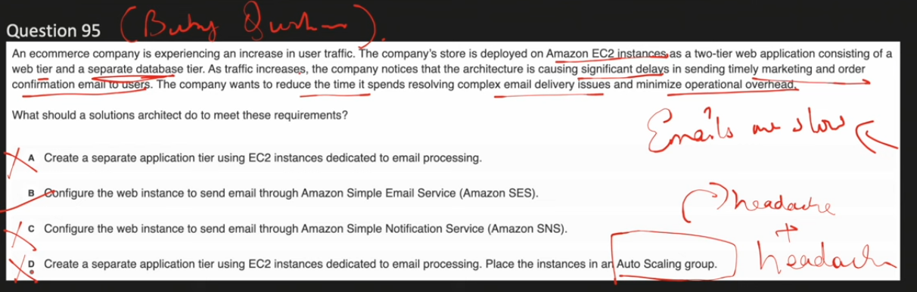

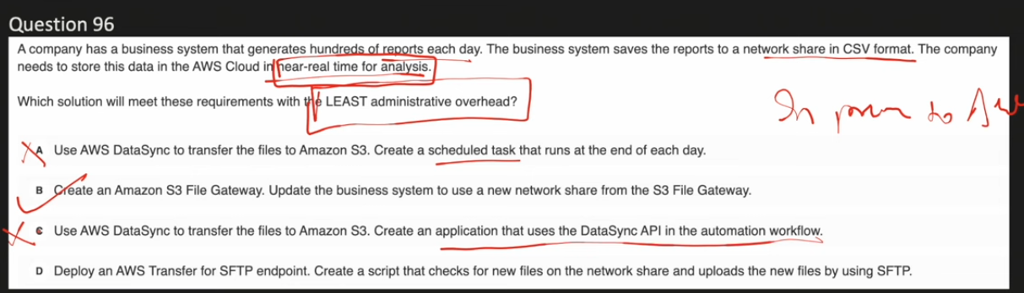

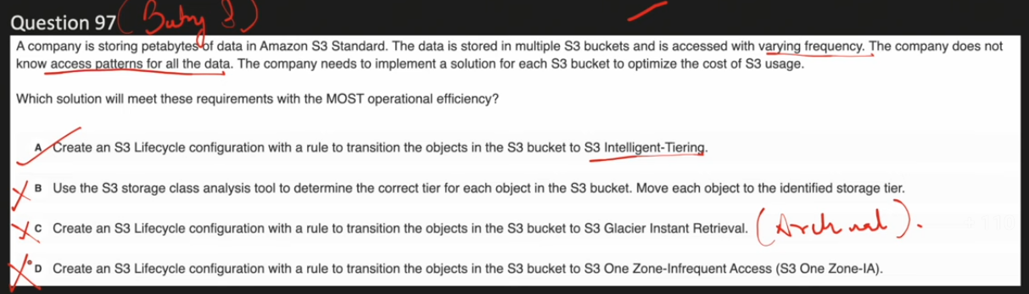

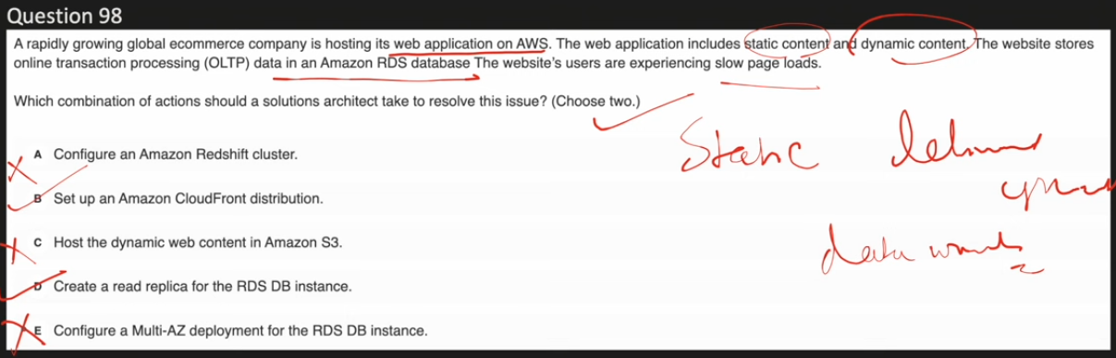

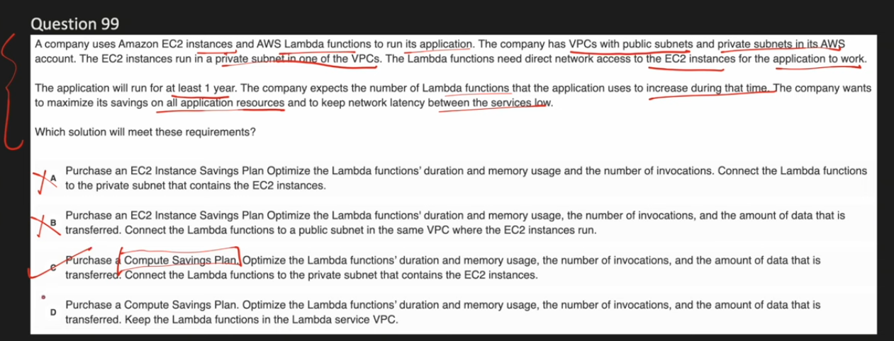

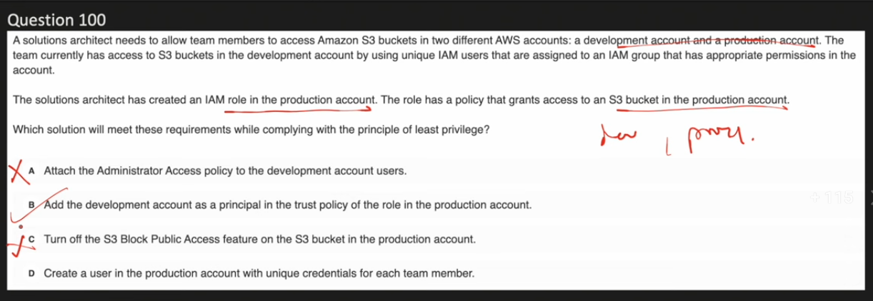

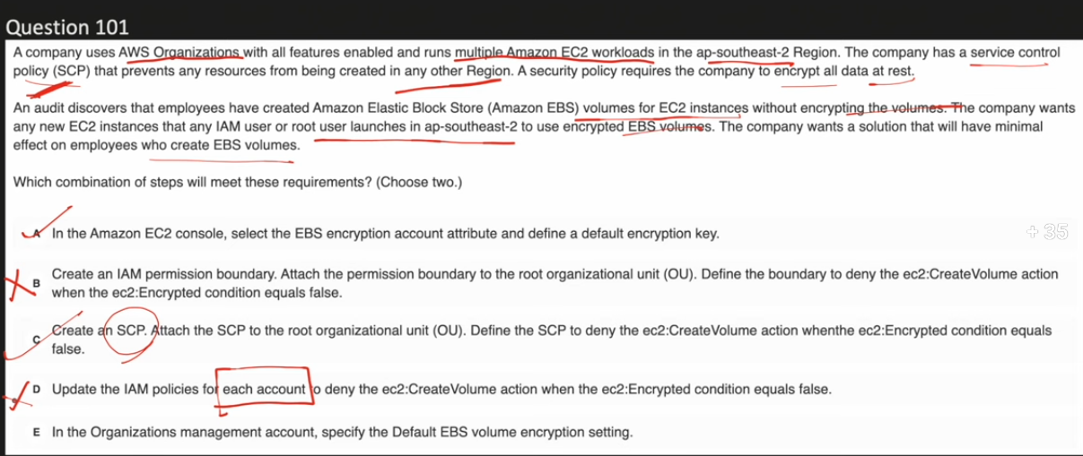

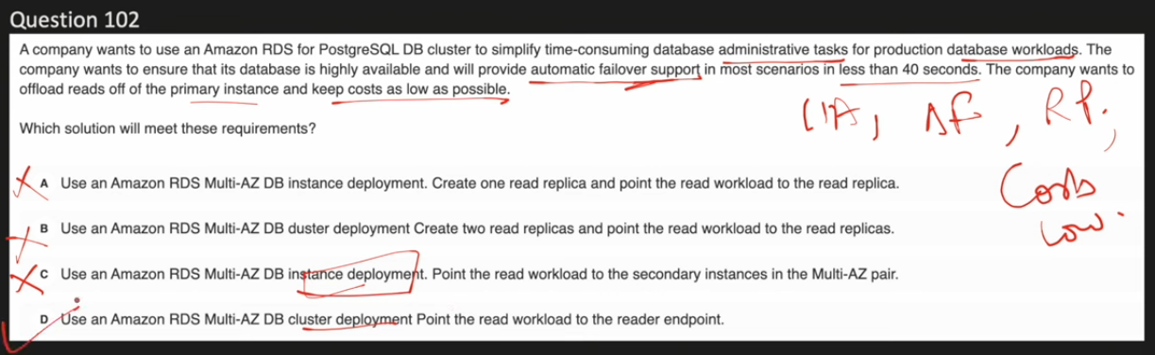

**Multi-AZ DB Cluster** is the latest deployment option for Amazon RDS PostgreSQL (and MySQL), offering enhanced performance and availability compared to traditional Multi-AZ deployments.

Key Features:

* Architecture - Consists of one primary (writer) DB instance and two readable standby instances, each in a separate Availability Zone
* Read Capability - Unlike traditional Multi-AZ where the standby is not accessible, both standby instances in a Multi-AZ DB cluster can serve read traffic
* Performance - Provides up to 2x faster commit latencies with semi-synchronous replication
* Faster Failover - Automated failover typically completes in under 35 seconds (compared to longer times in traditional Multi-AZ)
* Storage - Uses fast NVMe SSD for local storage, ideal for high-speed, low-latency operations

Traffic Distribution:

* Write traffic goes to the cluster endpoint (primary instance)
* Read traffic can be distributed to the reader endpoint (standby instances)

**Multi-AZ DB cluster deployment is not available for all RDS database engines. It is currently supported only for:**

* Amazon RDS for MySQL (version 8.0.26 and higher)
* Amazon RDS for PostgreSQL (version 13.4 and higher)

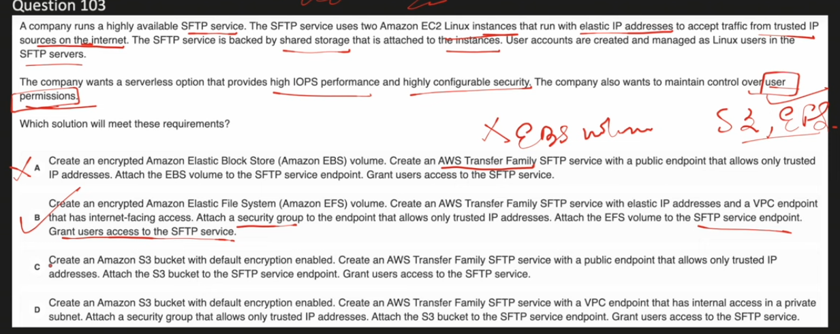

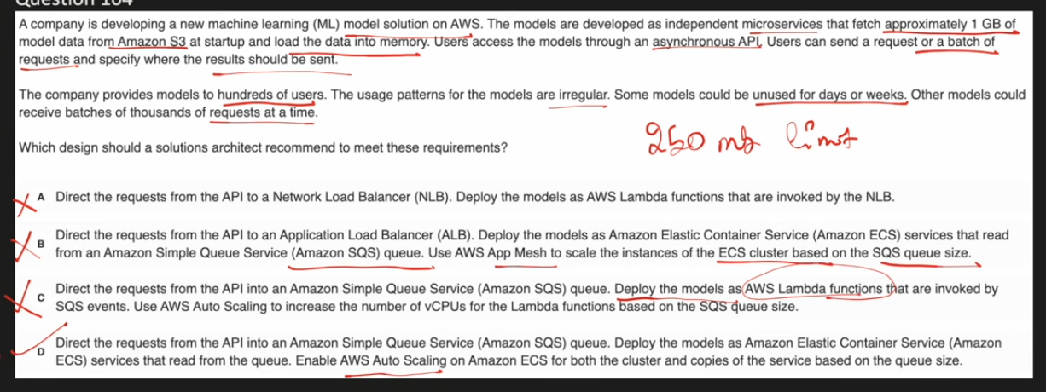

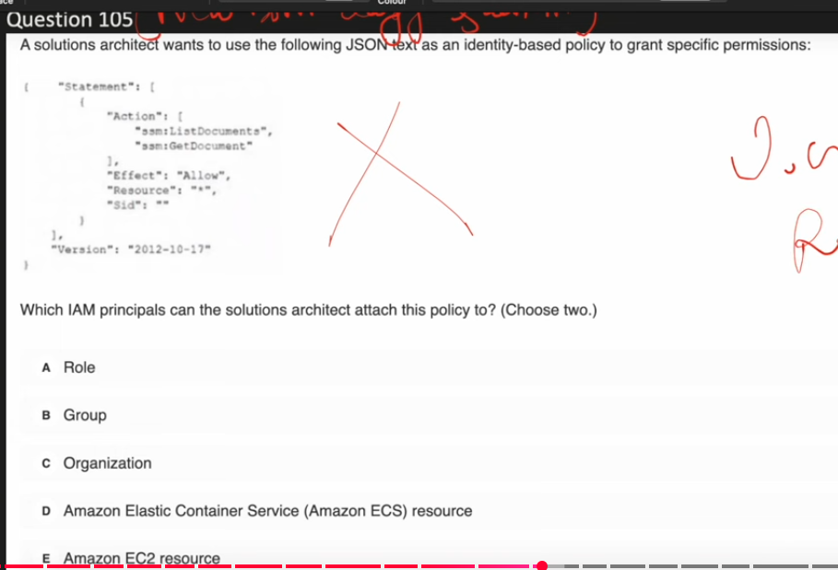

A & B – Correct for above question.

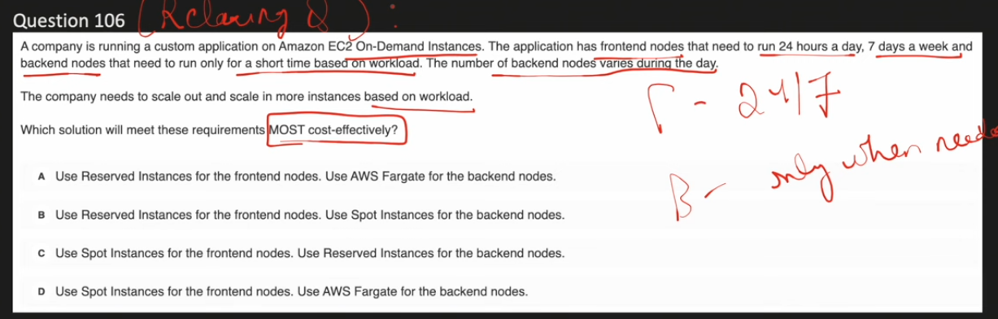

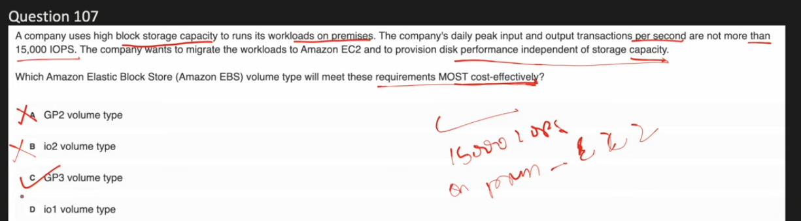

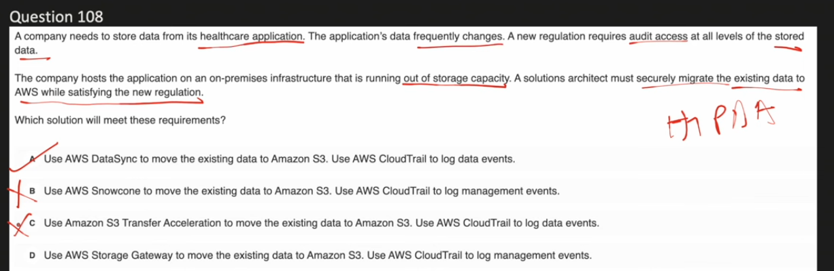

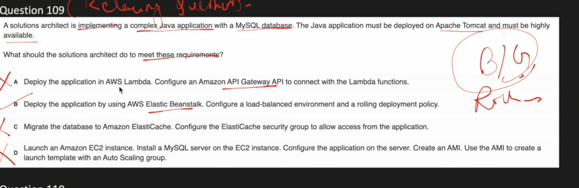

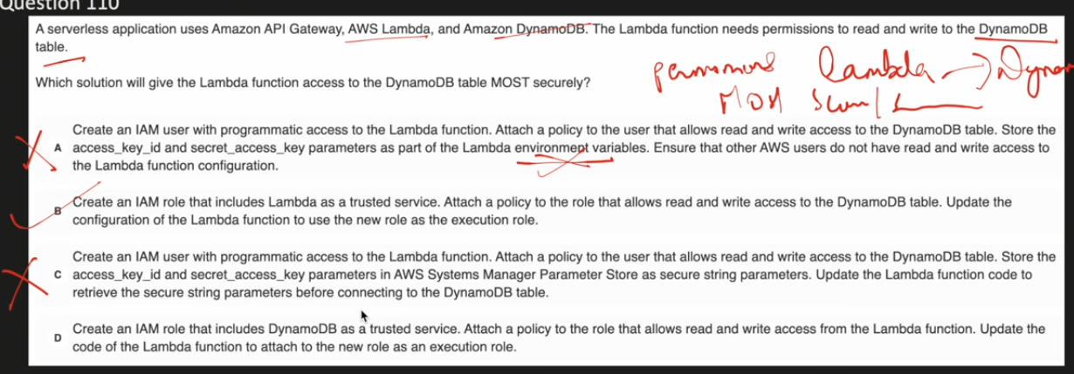

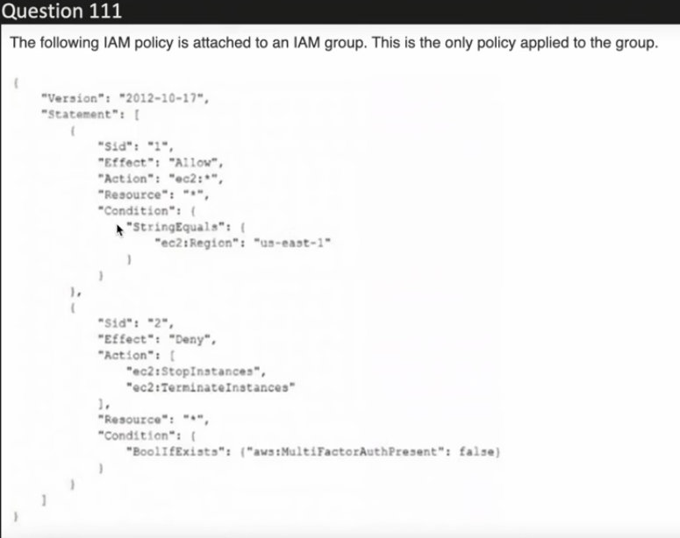

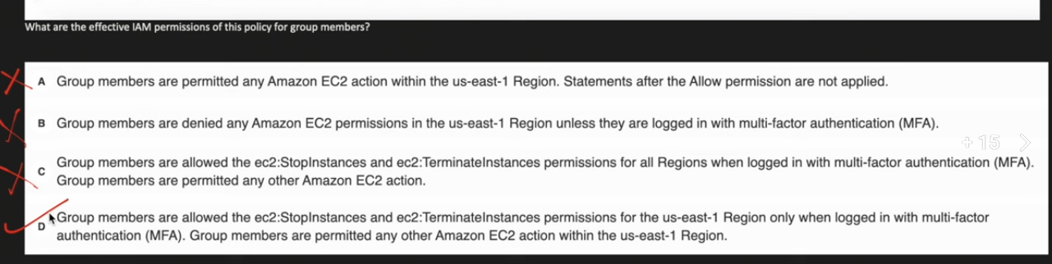

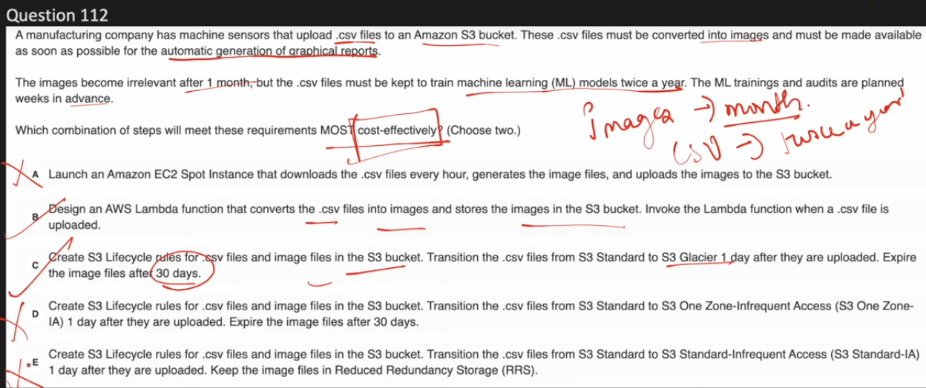

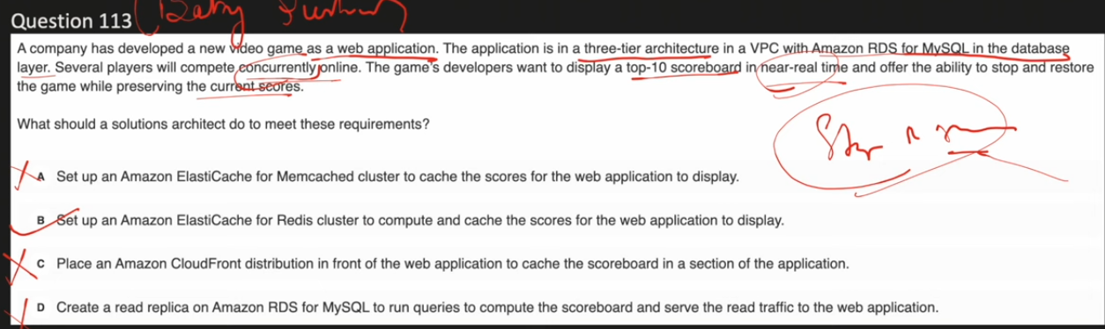

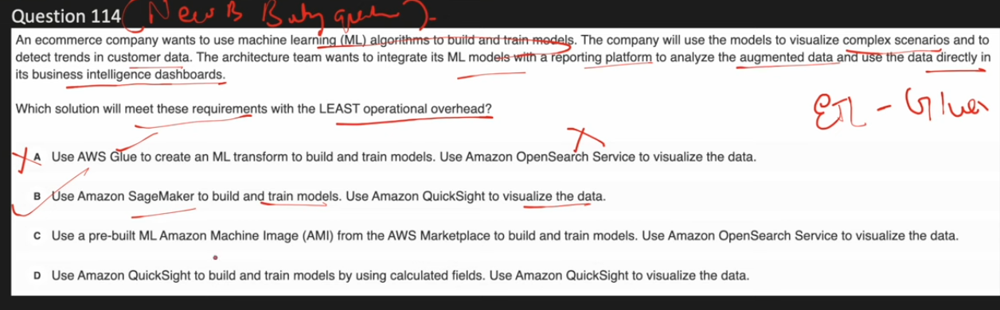

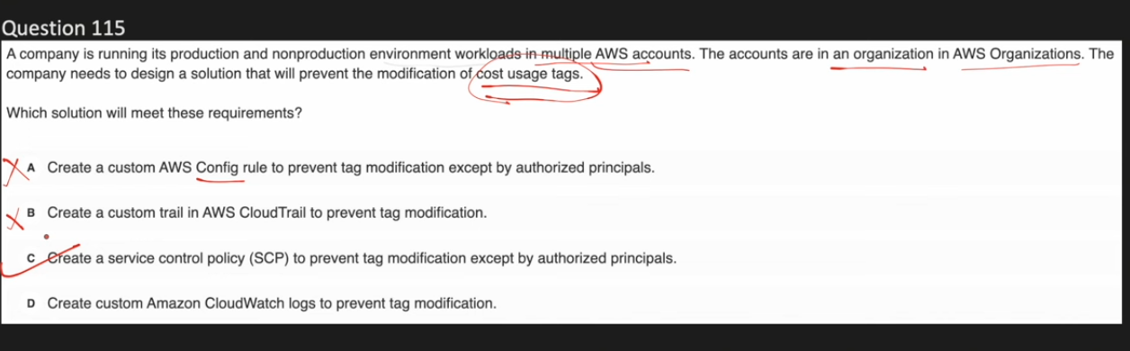

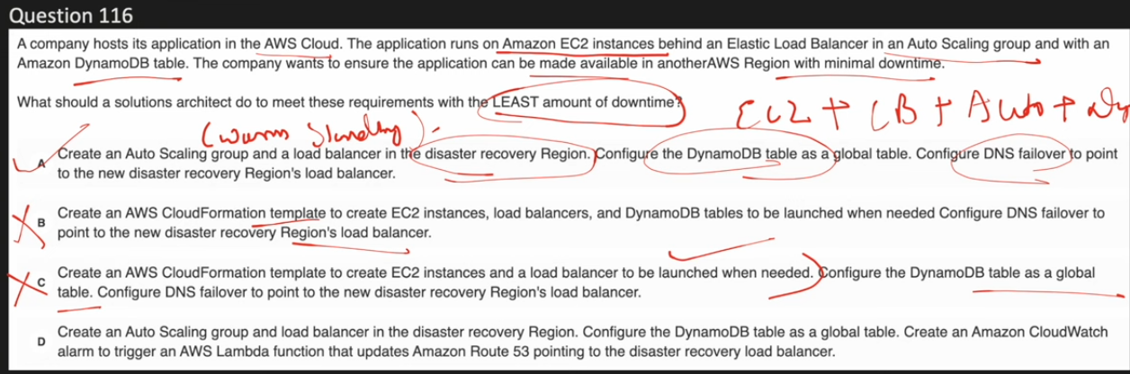

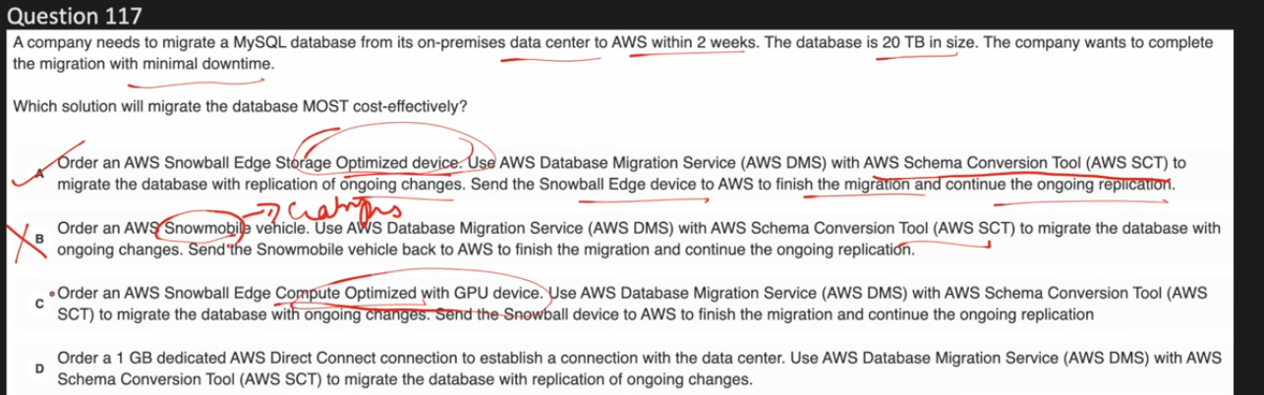**✅ A. Snowball Edge Storage Optimized + DMS**

Designed for **large-scale data transfer** at the lowest cost per TB, while DMS handles ongoing replication for minimal downtime.

### **❌ B. Snowmobile + DMS**

Snowmobile is intended for **petabyte-scale migrations** and is excessive and costly for a 20 TB database.

### **❌ C. Snowball Edge Compute Optimized + DMS**

Provides unnecessary compute/GPU capabilities, making it **more expensive than needed** for simple data migration.

### **❌ D. 1 Gbps Direct Connect + DMS**

Bandwidth may be insufficient to migrate 20 TB reliably within 2 weeks and is less cost-effective for one-time transfers.

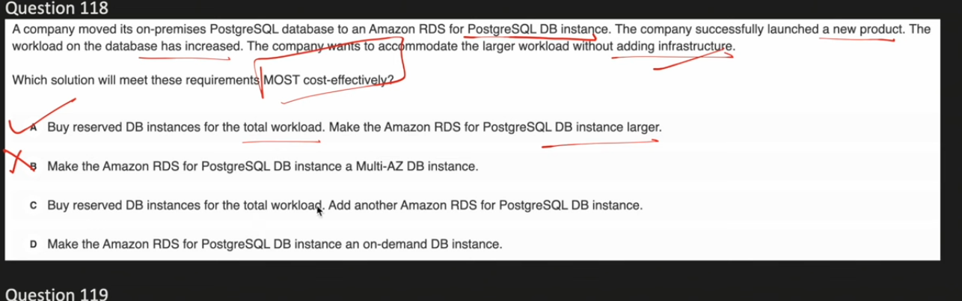

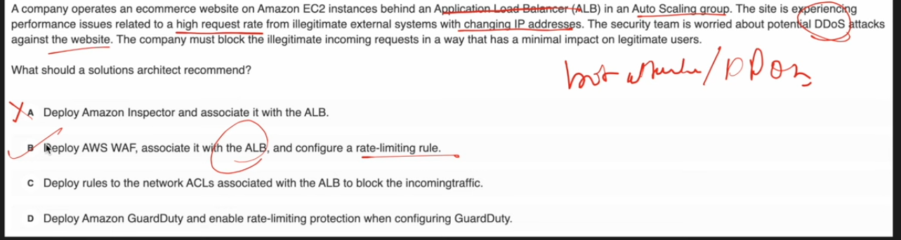

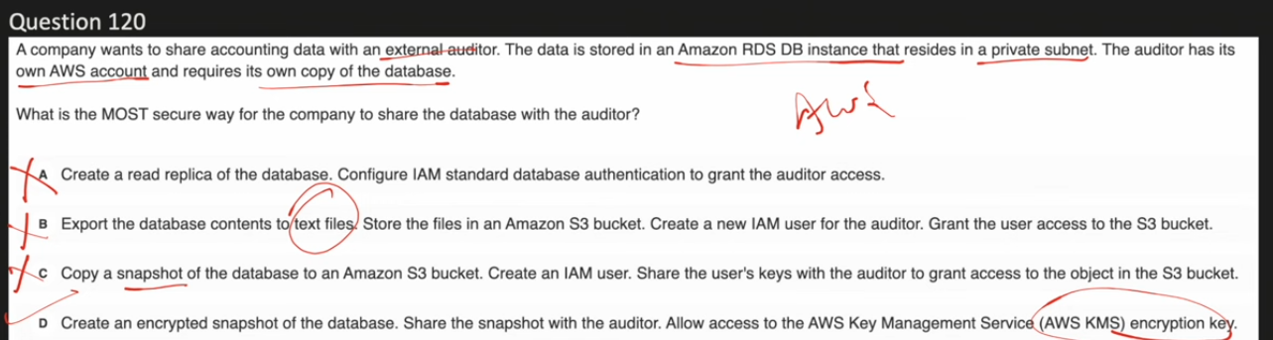

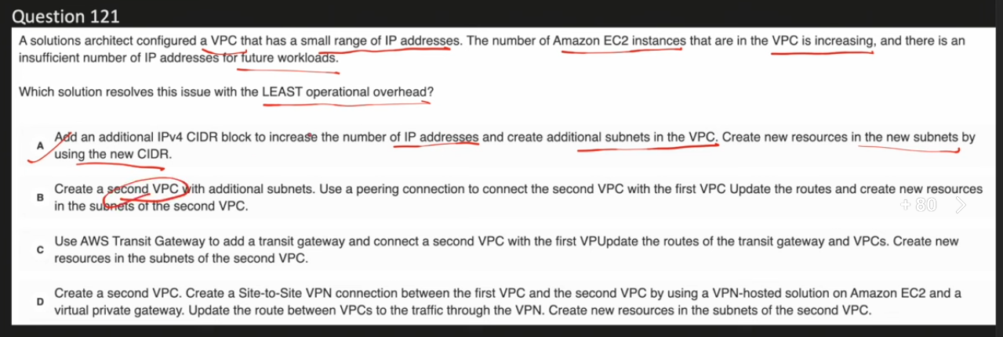

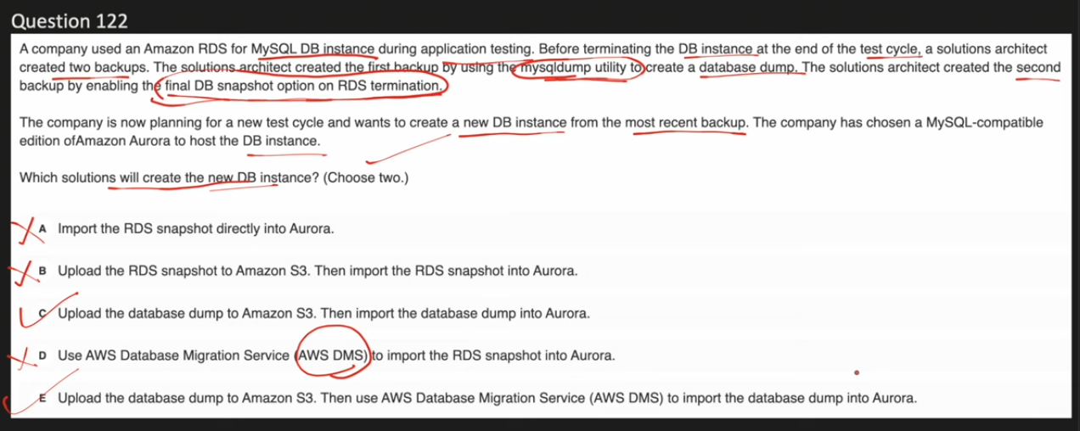

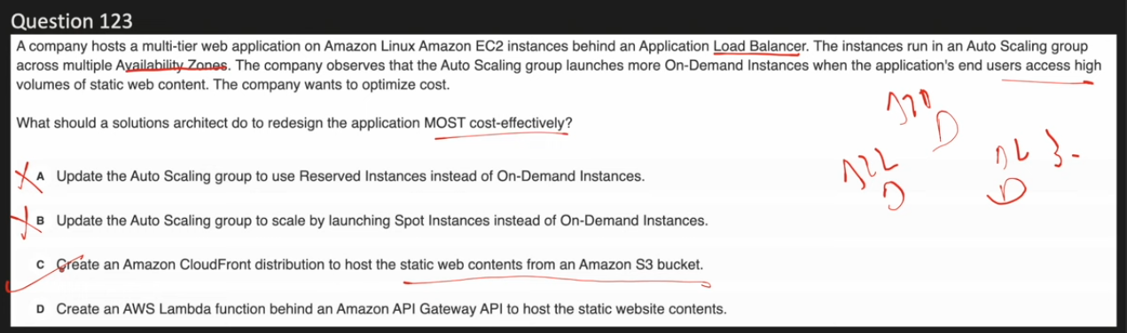

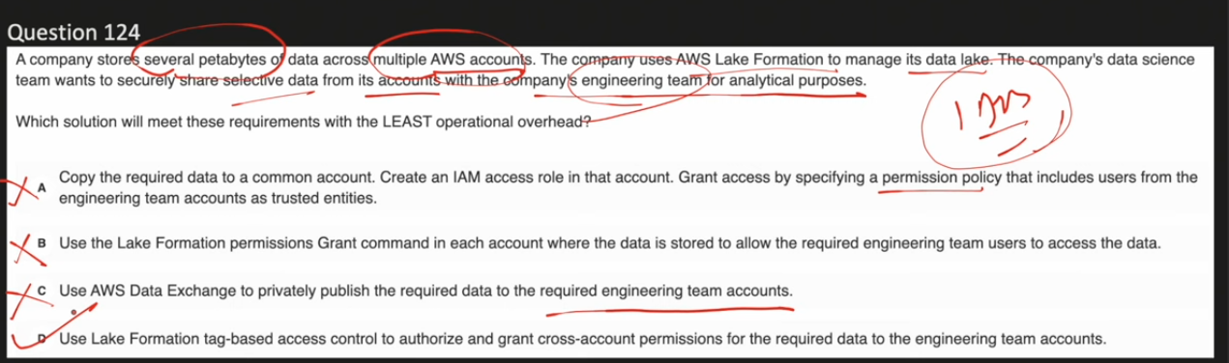

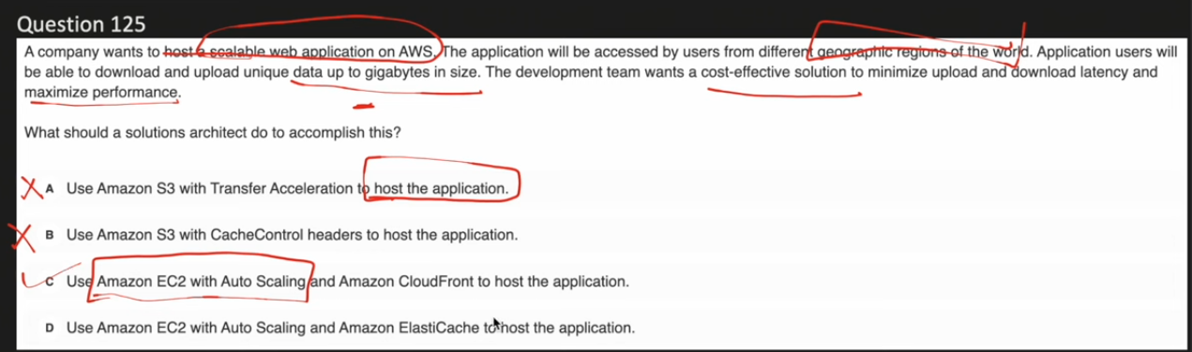

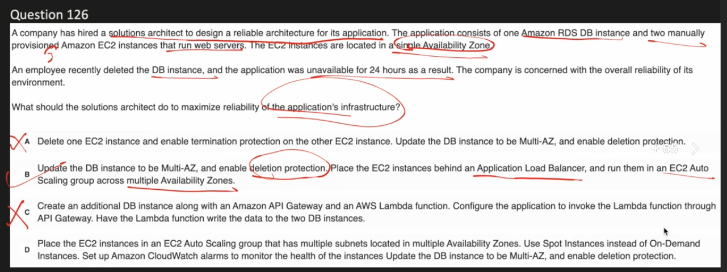

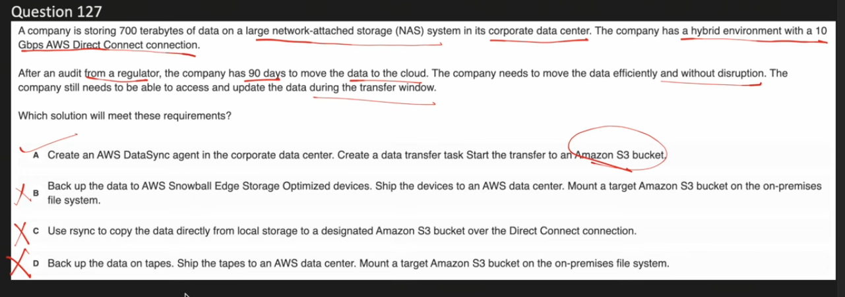

rsync is a command line tool, used to transfer the data from on-prem to aws using direct connect like aws datasync. the main advantage of this rsync is, it will transfer only the modified data when we re-run or re-transfer.

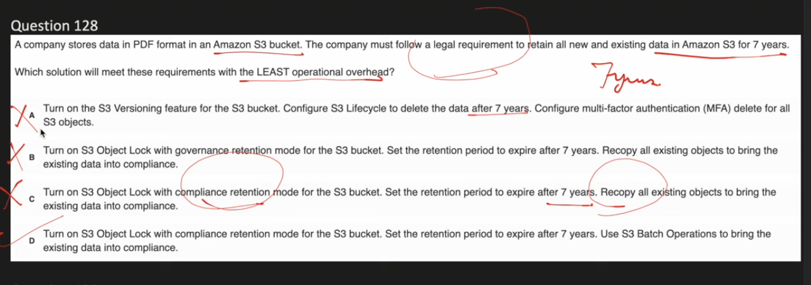

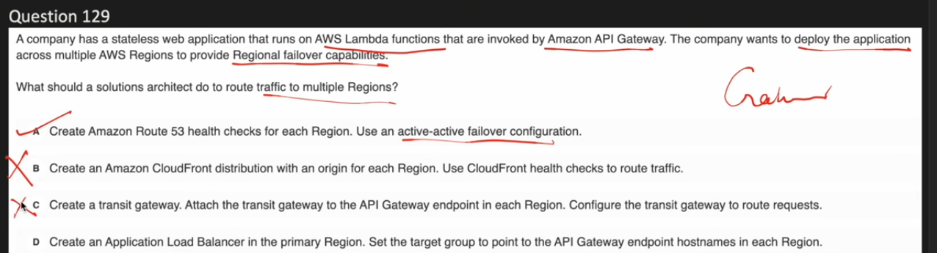

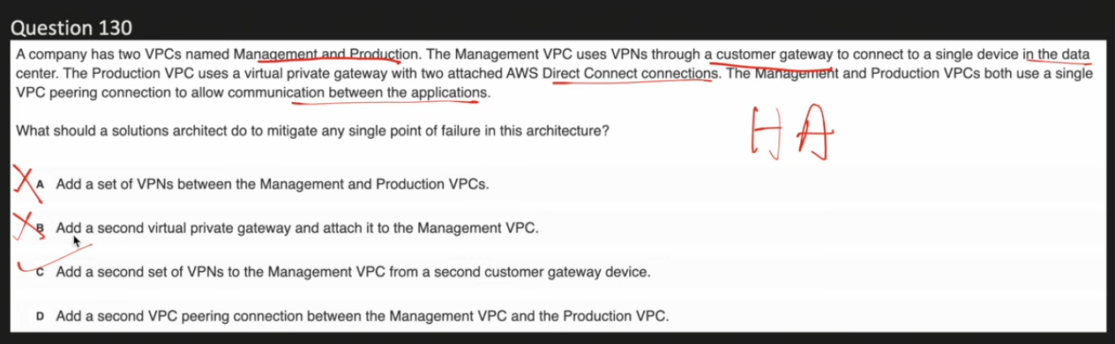

|  |  |  |
| --- | --- | --- |
| **Connection type** | **AWS side** | **On-prem side** |
| Site-to-Site VPN | VGW or TGW | **Customer Gateway** |
| Direct Connect | VGW or TGW | **DX router (physical)** |

VGW – Virtual private gateway.

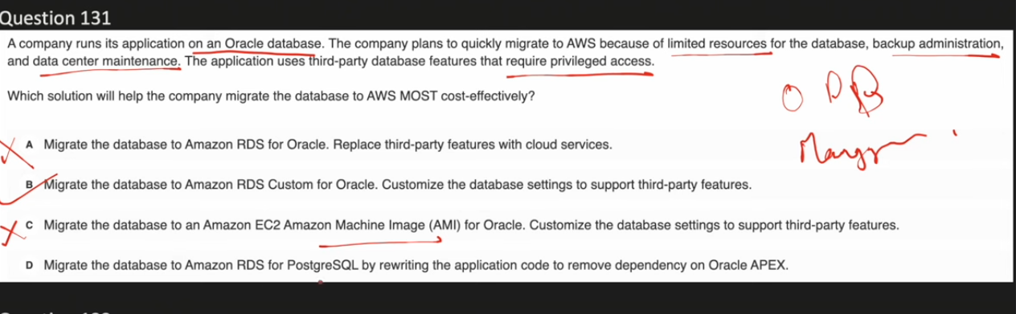

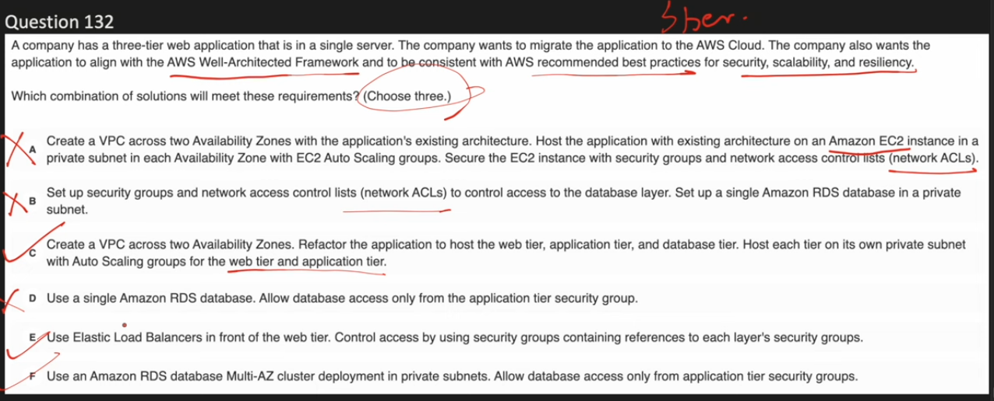

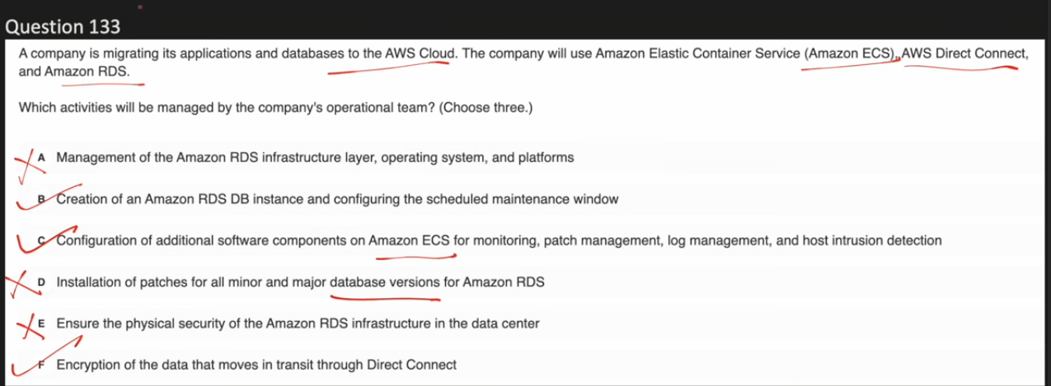

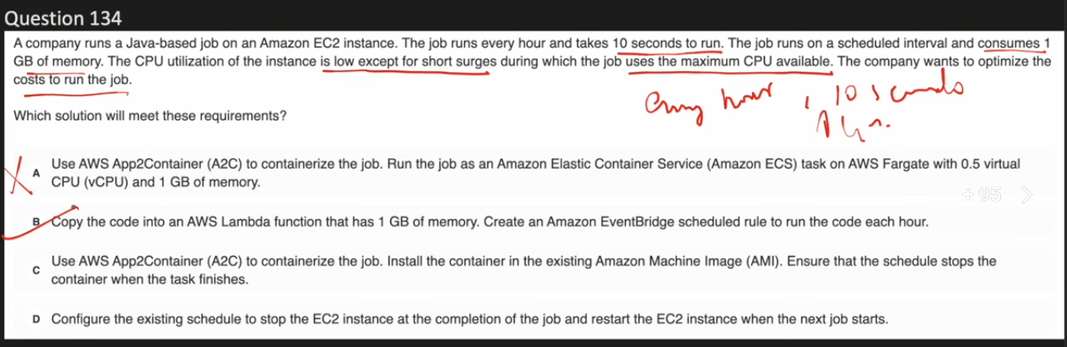

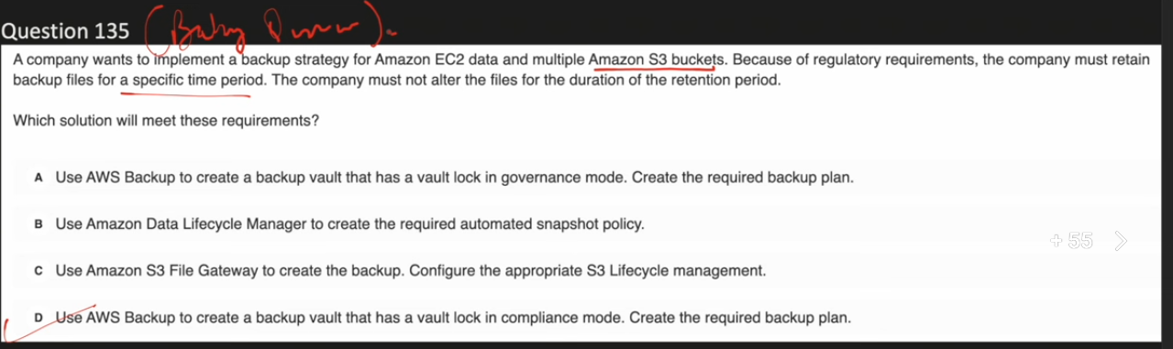

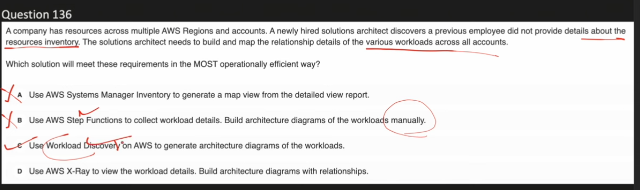

**AWS Workload Discovery on AWS**:

* Purpose: Visualizes and maps your existing AWS infrastructure and workloads
* Scope: Discovers AWS resources across accounts and regions
* Key Features:
  + Creates architecture diagrams based on live AWS data
  + Maps relationships between AWS resources
  + Multi-account and multi-region visualization
  + Cost analysis and reporting
  + Near real-time scanning (every 15 minutes)
* Use Case: Understanding your AWS architecture, visualizing resource relationships, and cost management

**AWS Systems Manager Inventory:**

* Purpose: Collects detailed metadata from managed instances (EC2 and on-premises)
* Scope: Focuses on instance-level configuration and software inventory
* Key Features:
  + Tracks installed applications, network configurations, and file metadata
  + Monitors Windows updates, services, and registry settings
  + Custom inventory collection capabilities
  + Software compliance tracking
  + Centralized metadata storage in Amazon S3
* Use Case: Configuration management, compliance tracking, and determining which instances need updates

Key Differences:

* Level of Detail: Workload Discovery provides high-level architecture views; Inventory provides deep instance-level metadata
* Focus: Workload Discovery maps resource relationships; Inventory tracks software and configurations
* Visualization: Workload Discovery creates diagrams; Inventory provides queryable data for analysis

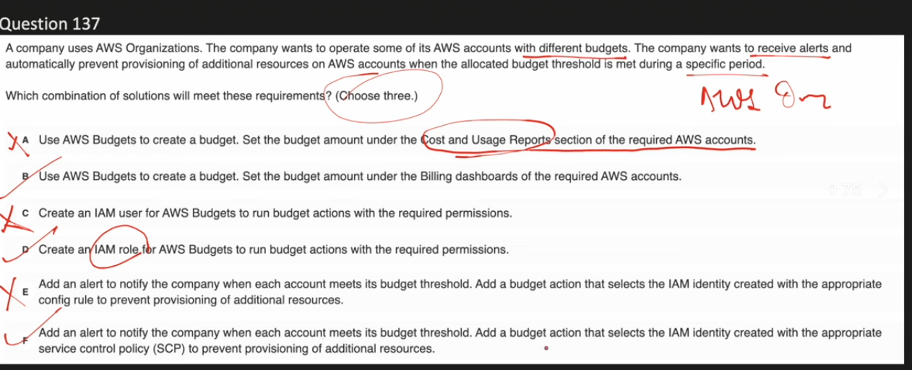

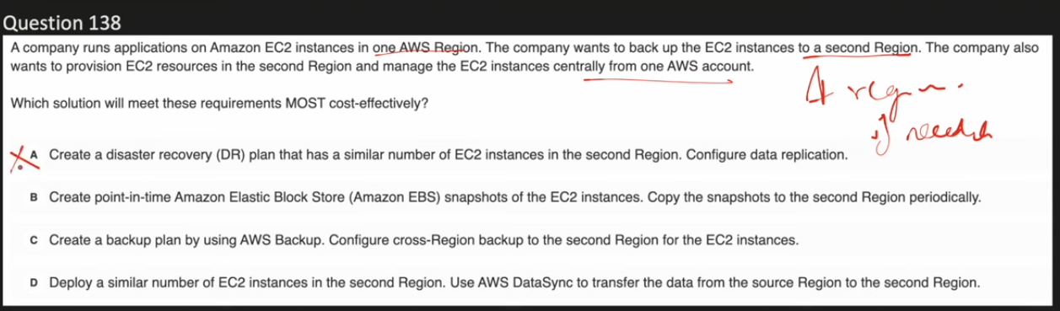

Option C is correct.

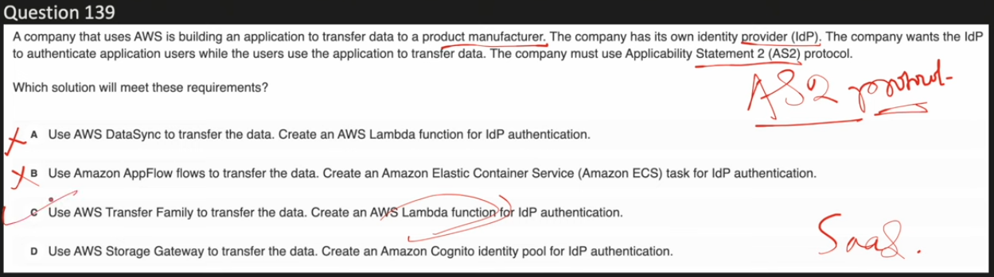

AWS Transfer Family supports multiple protocols, not just AS2:

Supported Protocols:

* SFTP (Secure File Transfer Protocol) - version 3
* FTPS (File Transfer Protocol Secure)
* FTP (File Transfer Protocol)
* AS2 (Applicability Statement 2)
* Browser-based transfers - for web-based file uploads and downloads

Key Points:

* Transfer Family is designed for business-to-business (B2B) file transfers with support for multiple protocols
* AS2 support was added on July 26, 2022, expanding the existing protocol options
* You can choose the protocol that best fits your trading partners' requirements
* All protocols enable secure file transfers directly into Amazon S3 buckets or Amazon EFS file systems

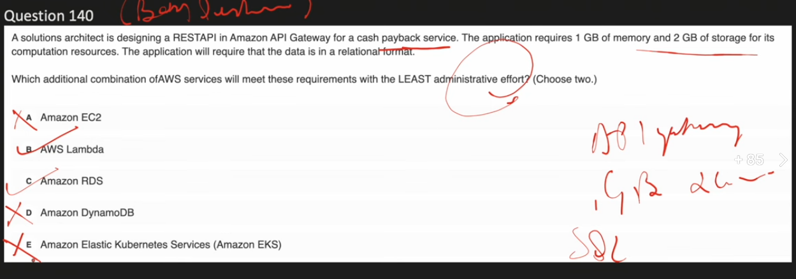

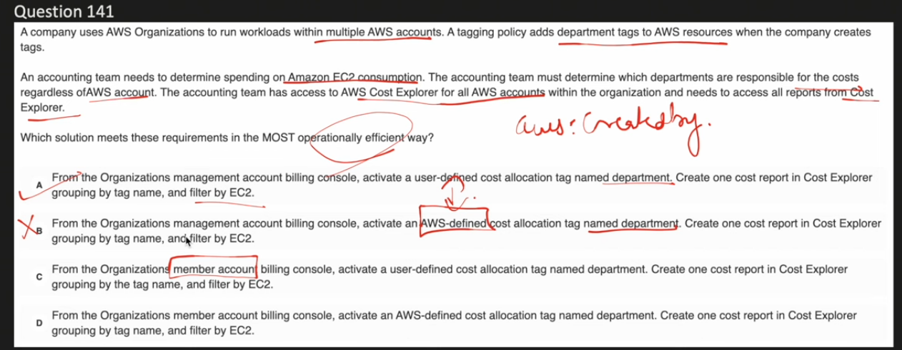

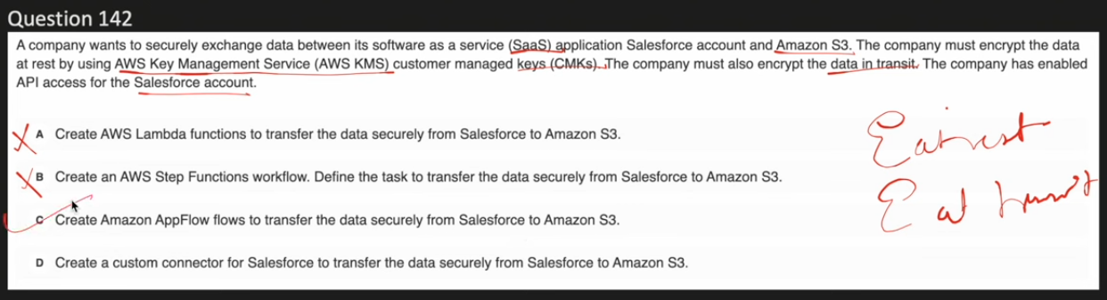

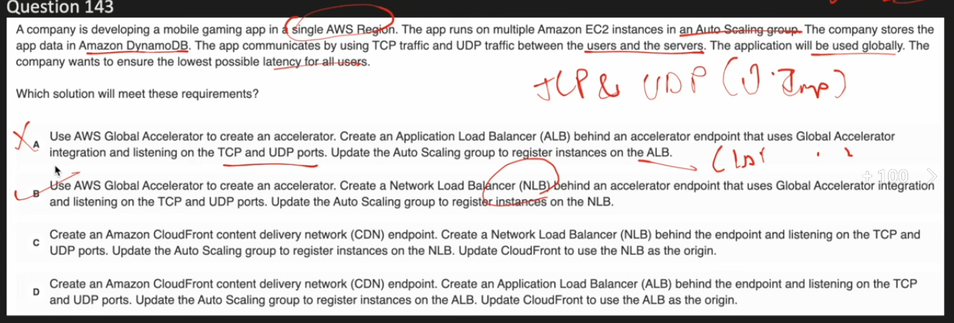

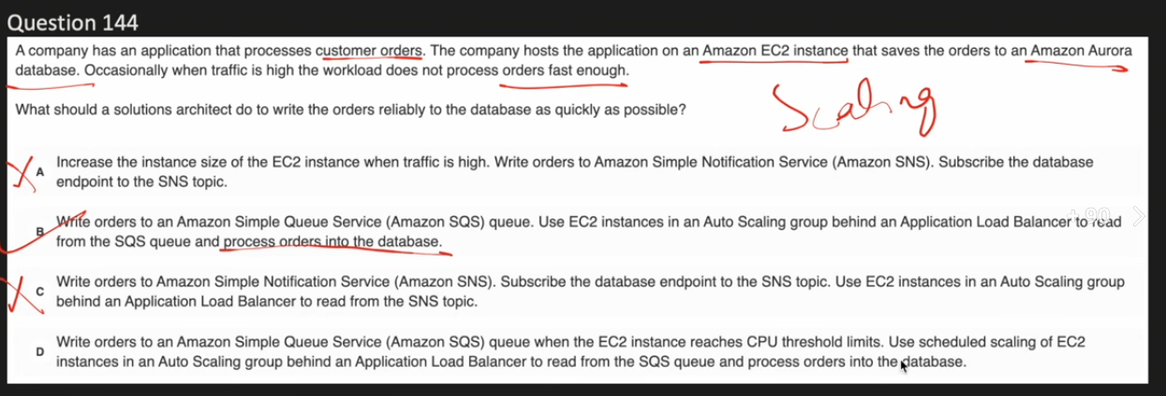

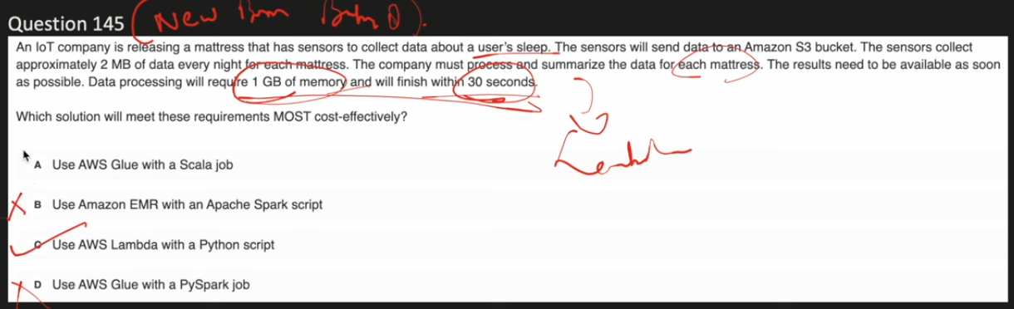

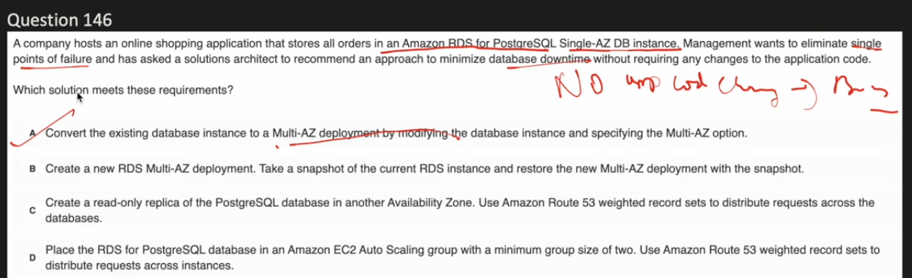

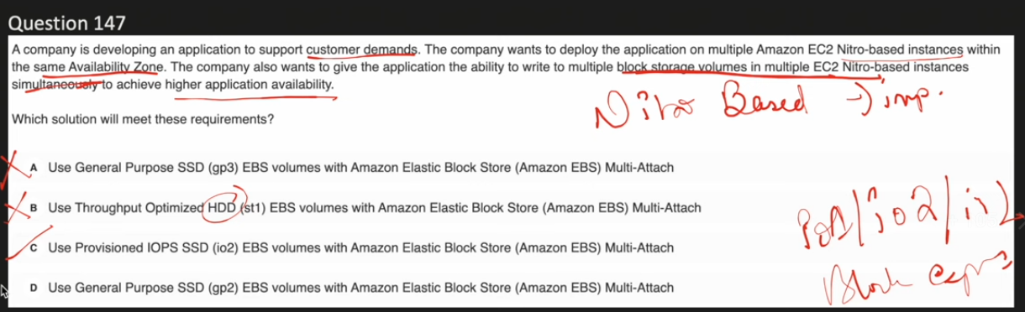

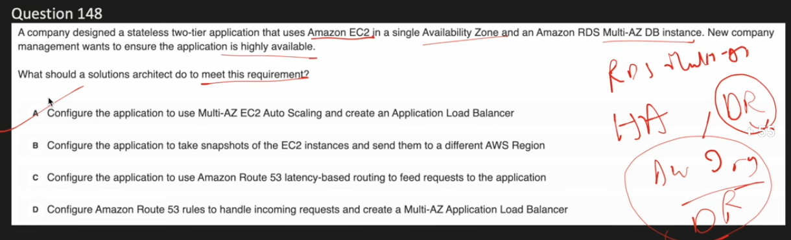

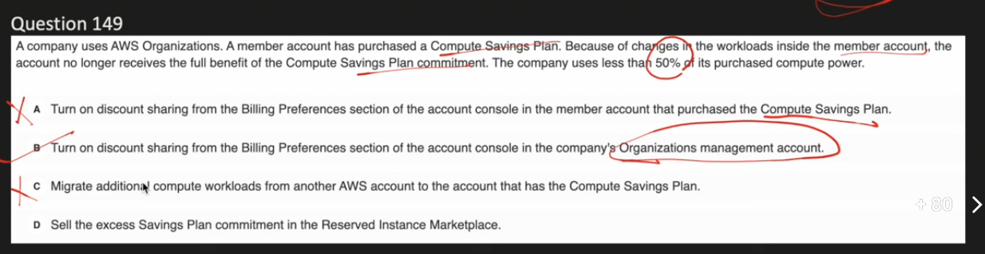

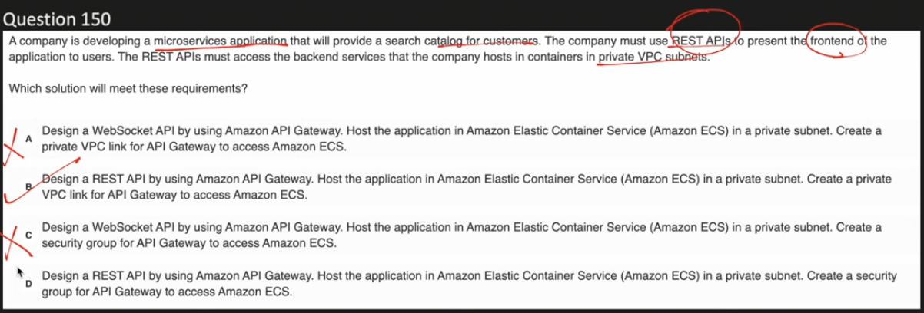

**A VPC link** is a resource in Amazon API Gateway that allows you to connect API routes to private resources inside a VPC. It acts as an abstraction layer that enables your API Gateway to securely access resources that are not publicly accessible.

Key Purpose:

* Connects API Gateway to private resources (like Application Load Balancers, Network Load Balancers, or services in private subnets)
* Acts like any other integration endpoint for an API
* Provides secure access without exposing backend resources to the public internet

Types of VPC Links:

1. VPC Link for REST APIs - Uses Network Load Balancer (NLB) to connect to private resources
2. VPC Link for HTTP APIs - Uses private integrations with Application Load Balancer (ALB), Network Load Balancer (NLB), or AWS Cloud Map for service discovery

How It Works:

* You create a VPC link and associate it with your load balancer or private resource
* Configure your API Gateway integration to use the VPC link
* API Gateway routes requests through the VPC link to your private resources
* Your backend services remain isolated in your VPC